 

**REALTIME FOREST FIRE DETECTION AND ALERTING SYSTEM**

### A PROJECT REPORT

***Submitted by***

# JEGATHEESWARAN K (927621BEC070) KARTHICK C (927621BEC072)

**KARTHIKEYAN S (927621BEC075) MAHENDRAVARMAN R S (927621BEC111)**

***in partial fulfillment for the award of the degree of***

# BACHELOR OF ENGINEERING

**in**

**ELECTRONICS AND COMMUNICATION ENGINEERING**

# M.KUMARASAMY COLLEGE OF ENGINEERING, KARUR ANNA UNIVERSITY: CHENNAI 600 025

 

**REALTIME FOREST FIRE DETECTION AND ALERTING SYSTEM**

### A PROJECT REPORT

***Submitted by***

# JEGATHEESWARAN K (927621BEC070) KARTHICK C (927621BEC072)

**KARTHIKEYAN S (927621BEC075) MAHENDRAVARMAN R S (927621BEC111)**

***in partial fulfillment for the award of the degree of***

# BACHELOR OF ENGINEERING

**in**

**ELECTRONICS AND COMMUNICATION ENGINEERING**

# M.KUMARASAMY COLLEGE OF ENGINEERING, KARUR ANNA UNIVERSITY: CHENNAI 600 025

### APRIL 2025

**M.KUMARASAMY COLLEGE OF ENGINEERING, KARUR**

# BONAFIDE CERTIFICATE

Certified that this project report **“REALTIME FOREST FIRE DETECTION AND ALERTING SYSTEM”** is the Bonafide work of **“JEGATHEESWARAN K (927621BEC070), KARTHICK C (927621BEC072), KARTHIKEYAN S (927621BEC075), MAHENDRAVARMAN R S**

**(927621BEC111)”** who carried out the project work under my supervision in the academic year 2024–2025.

|  |  |
| --- | --- |
| **SIGNATURE** | **SIGNATURE** |
| **Dr.A.KAVITHA, M.E.,Ph.D.,** | **Ms.S.VASUKI, M.E.,** |
| **HEAD OF THE DEPARTMENT**  Professor,  Department of Electronics and Communication Engineering, M.Kumarasamy College of Engineering, Thalavapalayam, Karur-639113 | **SUPERVISOR**  Assistant Professor**,** Department of Electronics and Communication Engineering,  M.Kumarasamy College of Engineering,  Thalavapalayam, Karur-639113 |

This project report has been submitted for the **18ECP107L - Project Work** Viva Voce Examination held at M. Kumarasamy College of Engineering, Karur on .

**INTERNAL EXAMINER EXTERNAL EXAMINER**

# INSTITUTION VISION AND MISSION

**Vision**

To emerge as a leader among the top institutions in the field of technical education.

**Mission**

**M1:** Produce smart technocrats with empirical knowledge who can surmount the global challenges.

**M2:** Create a diverse, fully -engaged, learner -centric campus environment to provide quality education to the students.

**M3:** Maintain mutually beneficial partnerships with our alumni, industry and professional associations

# DEPARTMENT VISION, MISSION, PEO, PO AND PSO

**Vision**

To empower the Electronics and Communication Engineering students with emerging technologies, professionalism, innovative research and social responsibility.

**Mission**

**M1:** Attain the academic excellence through innovative teaching learning process, research areas & laboratories and Consultancy projects.

**M2:** Inculcate the students in problem solving and lifelong learning ability.

**M3:** Provide entrepreneurial skills and leadership qualities.

**M4:** Render the technical knowledge and skills of faculty members.

**Program Educational Objectives**

**PEO1: Core Competence:** Graduates will have a successful career in academia or industry associated with Electronics and Communication Engineering

**PEO2: Professionalism:** Graduates will provide feasible solutions for the challenging problems through comprehensive research and innovation in the allied areas of Electronics and Communication Engineering.

**PEO3: Lifelong Learning:** Graduates will contribute to the social needs through lifelong learning, practicing professional ethics and leadership quality.

**Program Outcomes**

**PO 1: Engineering knowledge:** Apply the knowledge of mathematics, science, engineering fundamentals, and an engineering specialization to the solution of complex engineering problems.

**PO 2: Problem analysis:** Identify, formulate, review research literature, and analyze complex engineering problems reaching substantiated conclusions using first principles of mathematics, natural sciences, and engineering sciences.

**PO 3: Design/development of solutions:** Design solutions for complex engineering problems and design system components or processes that meet the specified needs with appropriate consideration for the public health and safety, and the cultural, societal, and environmental considerations.

**PO 4: Conduct investigations of complex problems:** Use research-based knowledge and research methods including design of experiments, analysis

and interpretation of data, and synthesis of the information to provide valid conclusions.

**PO 5: Modern tool usage:** Create, select, and apply appropriate techniques, resources, and modern engineering and IT tools including prediction and modeling to complex engineering activities with an understanding of the limitations.

**PO 6: The engineer and society:** Apply reasoning informed by the contextual knowledge to assess societal, health, safety, legal and cultural issues and the consequent responsibilities relevant to the professional engineering practice.

**PO 7: Environment and sustainability:** Understand the impact of the professional engineering solutions in societal and environmental contexts, and demonstrate the knowledge of, and need for sustainable development.

**PO 8: Ethics:** Apply ethical principles and commit to professional ethics and responsibilities and norms of the engineering practice.

**PO 9: Individual and team work:** Function effectively as an individual, and as a member or leader in diverse teams, and in multidisciplinary settings.

**PO 10: Communication:** Communicate effectively on complex engineering activities with the engineering community and with society at large, such as, being able to comprehend and write effective reports and design documentation, make effective presentations, and give and receive clear instructions.

**PO 11: Project management and finance:** Demonstrate knowledge and understanding of the engineering and management principles and apply

these to one’s own work, as a member and leader in a team, to manage projects and in multidisciplinary environments.

**PO 12: Life-long learning:** Recognize the need for, and have the preparation and ability to engage in independent and life-long learning in the broadest context of technological change.

**Program Specific Outcomes**

**PSO1:** Applying knowledge in various areas, like Electronics, Communications, Signal processing, VLSI, Embedded systems etc., in the design and implementation of Engineering application.

**PSO2:** Able to solve complex problems in Electronics and Communication Engineering with analytical and managerial skills either independently or in team using latest hardware and software tools to fulfil the industrial expectations.

|  |  |
| --- | --- |
| **Abstract** | **Matching with POs, PSOs** |
| Fire detection, environmental monitoring, temperature | PO1, PO2, PO6, PO7, PO9, PO12, PSO1, PSO2 |

|  |  |  |
| --- | --- | --- |
| **S.No.** | **Project Domain** | **Mapping with POs/PSOs** |
| 1. | Digital Signal Processing | PO1, PO2, PO3, PO4, PO5, PO6, PO7, PO8, PO9, PO10, PO11, PO12, PSO1, PSO2 |
| 2. | Embedded Systems | PO1, PO2, PO3, PO4, PO6, PO7, PO9, PO12, PSO1, PSO2 |
| 3. | IoT | PO1, PO2, PO3, PO4, PO5, PO6, PO8, PO9, PO10, PO11, PO12, PSO1, PSO2 |
| 4. | Wireless Communication and Networks | PO1, PO2, PO3, PO4, PO5, PO8, PO9, PO10, PO11, PO12, PSO1, PSO2 |

# ACKNOWLEDGEMENT

We gratefully remember our beloved **Founder Chairman, (Late) Thiru. M. Kumarasamy**, whose vision and legacy laid the foundation for our education and inspired us to successfully complete this project.

We extend our sincere thanks to **Dr. K. Ramakrishnan, Chairman**, and **Mr. K. R. Charun Kumar, Joint Secretary**, for providing excellent infrastructure and continuous support throughout our academic journey.

We are privileged to extend our heartfelt thanks to our respected Principal, **Dr. B. S. Murugan, B.Tech., M.Tech., Ph.D.,** for providing us with a conducive environment and constant encouragement to pursue this project work.

We sincerely thank **Dr. A. Kavitha, B.E., M.E., Ph.D.,** Professor and **Head, Department of Electronics and Communication Engineering**, for her continuous support, valuable guidance, and motivation throughout the course of this project.

Our special thanks and deep sense of appreciation go to our **Project Supervisor, Ms. S. Vasuki, B.E., M.E.,** Assistant Professor, **Department of Electronics and Communication Engineering,** for her exceptional guidance, continuous supervision, constructive suggestions, and unwavering support, all of which have been instrumental in the successful execution of this project.

We would also like to acknowledge **Dr. S. Vimalnath, B.E., M.E., Ph.D., Assistant Professor, our Class Advisor,** and **Dr. S. Vimalnath**, **B.E., M.E., Ph.D.,** the **Project Coordinator**, for their constant encouragement and coordination that contributed to the smooth progress and completion of our project work.

We gratefully thank all the **faculty members of the Department of Electronics and Communication Engineering** for their timely assistance, valuable insights, and constant support during various phases of the project.

Finally, we extend our profound gratitude to our **parents and friends** for their encouragement, moral support, and motivation, without which the successful completion of this project would not have been possible.

### ABSTRACT

This system aims to enhance fire safety by continuously monitoring environmental conditions, detecting fires, and identifying hazardous gas levels in real time. It integrates various sensors, including temperature, humidity, flame, and gas sensors, to assess potential fire risks efficiently. The system provides continuous monitoring of environmental factors that can influence fire outbreaks, such as temperature and humidity, allowing for the early detection of abnormal conditions. A flame sensor ensures the immediate identification of a fire, triggering the system’s alert mechanisms to ensure rapid response. In addition to fire detection, the system tracks hazardous gases such as carbon monoxide and methane. It continuously analyzes these gases to detect any abnormal levels that could indicate a fire emergency. When the system detects either fire or hazardous gases, it activates a loud alarm to warn individuals in the vicinity, facilitating quick action to mitigate risks. Real-time data from the sensors is displayed on an intuitive user interface, providing an up-to-date overview of environmental conditions and system status. This system is designed for a variety of applications, including industrial environments, homes, and public spaces, where early detection of fire and hazardous gas levels is crucial for safety. Its integration of real-time data monitoring and remote alerts enhances the ability to respond promptly to potential emergencies, providing a reliable solution for fire risk management.

**Keywords:** Fire detection, environmental monitoring, temperature, humidity, hazardous gases, flame sensor.

**TABLE OF CONTENTS**

|  |  |  |  |
| --- | --- | --- | --- |
| **CHAPTER**  **No.** |  | **CONTENTS** | **PAGE**  **No.** |
|  | **INSTITUTION VISION AND MISSION** | | iii |
|  | **DEPARTMENT VISION AND MISSION** | | iii |
|  | **DEPARTMENT PEOS, POS AND PSOS** | | iv |
|  | **ABSTRACT** | | ix |
|  | **LIST OF TABLES** | | xii |
|  | **LIST OF FIGURES** | | xiii |
|  | **LIST OF ABBREVIATIONS** | | xiv |
| **1** | **INTRODUCTION** | | **1** |
|  | 1.1 | Introduction to Fire Safety Challenges | 4 |
|  | 1.2 | Multi-Sensor Integration for Risk Assessment | 4 |
|  | 1.3 | Monitoring Temperature and  Humidity to Prevent Fire Outbreaks | 4 |
|  | 1.4 | Immediate Flame Detection for Rapid  Response | 5 |
|  | 1.5 | Hazardous Gas Monitoring for Toxic  Threats | 5 |
|  | 1.6 | Real-Time Data Visualization and  User Interface | 5 |
|  | 1.7 | Remote Monitoring and IoT  Integration | 6 |
|  | 1.8 | Versatile Applications Across  Multiple Environments | 6 |
|  | 1.9 | A Step Toward Smarter, Safer Infrastructure | 6 |
| **2** | **LITERATURE SURVEY** | | **7** |
|  | 2.1 | Wireless Sensor Network for the Detection of Forest Fires | 7 |
|  | 2.2 | Enhanced Chromatic Segmentation and Optical Flow Model | 7 |

|  |  |  |  |
| --- | --- | --- | --- |
|  | 2.3 | Forest Fire Smoke Detection | 8 |
|  | 2.4 | Forest Fire Susceptibility Zonation with IoT Sensor Network Support. | 8 |
|  | 2.5 | Forest Fire Detection System Using  Wireless Sensor Network | 9 |
|  | 2.6 | Smart Fire Detection System Using IoT  Technology | 9 |
|  | 2.7 | Fully Smart Fire Detection and Prevention in the Authorized Forests. | 9 |
| **3** | **EXISTING SYSTEM`** | | **11** |
|  | 3.1 | Existing technique | 11 |
|  | 3.2 | Objective | 11 |
| **4** | **PROPOSED SYSTEM** | | **13** |
|  | 4.1 Explanation | | 16 |
|  | 4.2 Proposed Technique | | 17 |
|  | 4.3 Applications | | 17 |
|  | 4.4 Circuit Diagram | | 19 |
|  | 4.5 Circuit Explanation | | 19 |
| **5** | **METHODOLOGY** | | 21 |
|  | 5.1 Module Explanations | | 21 |
| **6** | **SOFTWARE REQUIREMENTS** | | **26** |
|  | 6.1 Arduino IDE | | 26 |
|  | 6.2 Special pin functions | | 28 |
|  | 6.3 DHT11 Sensor | | 29 |
|  | 6.4 Flame Sensor | | 31 |
|  | 6.5 Buzzer | | 33 |
|  | 6.6 Libraries | | 35 |

|  |  |  |
| --- | --- | --- |
|  | 6.7 Connecting the Arduino | 35 |
|  | 6.8 Preparing the Board | 36 |
|  | 6.9 Loading the code | 36 |
|  | 6.10 Proteus | 37 |
| **7** | **SOFWARE DESCRIPTION** | **39** |
| **8** | **RESULTS AND DISCUSSION** | **44** |
| **9** | **CONCLUSION AND FUTURE WORK** | **49** |
|  | **APPENDICES** | **53** |
|  | **REFERENCES** | **65** |

**LIST OF TABLES**

|  |  |  |
| --- | --- | --- |
| **TABLE No.** | **TITLE** | **PAGE No.** |
| 6.1 | Arduino Pin Functions | 28 |
| 6.2 | DHT11 Sensor | 30 |
| 6.3 | Flame Sensor | 32 |

**LIST OF FIGURES**

|  |  |  |
| --- | --- | --- |
| **FIGURE**  **No.** | **TITLE** | **PAGE No.** |
| 1.1 | Forest Fire detection System | 1 |
| 4.1 | Block Diagram | 16 |
| 4.2 | Circuit Diagram | 19 |
| 6.1 | Arduino IDE Software | 27 |
| 6.2 | Arduino UNO with Gas Sensor | 29 |
| 6.3 | Temperature sensor | 30 |
| 6.4 | Temperature sensor with Arduino UNO | 31 |
| 6.5 | Flame Sensor | 32 |
| 6.6 | Flame sensor with Arduino UNO | 33 |
| 6.7 | Buzzer | 34 |
| 6.8 | Buzzer with Arduino UNO | 34 |
| 6.9 | Proteus Software app icon | 37 |
| 7.1 | Blynk app homepage | 42 |
| 7.2 | Fire alert page in blynk application | 43 |
| 8.1 | Results of detection in Blynk App | 44 |
| 8.2 | Project module | 46 |

**LIST OF ABBREVIATIONS**

|  |  |  |
| --- | --- | --- |
| **ACRONYM** |  | **ABBREVIATION** |
| IoT | - | Internet of Things |
| LCD | - | Liquid Crystal Display |
| WSN | - | Wireless Sensor Network |
| GPS | - | Global Positioning System |
| GIS | - | Geographic Information System |

# CHAPTER 1

### INTRODUCTION

Fire safety remains one of the most critical concerns across residential, industrial, and public environments due to the potentially devastating consequences of uncontrolled fire outbreaks and hazardous gas leaks. Traditional fire detection systems, while effective in many cases, often suffer from delayed response times and limited monitoring capabilities, particularly in scenarios where individuals are not immediately present to take action. In light of these limitations, there is an increasing demand for intelligent, real-time monitoring systems that can continuously assess environmental parameters and promptly detect fire risks and gas hazards. This project addresses that demand through the development of a comprehensive fire safety monitoring system that integrates multiple sensors and modern communication technologies to enhance both detection accuracy and response speed. By incorporating temperature, humidity, flame, and gas sensors, the system provides a multi-layered approach to detecting and responding to fire hazards, ensuring that no single point of failure compromises the safety of the monitored area.

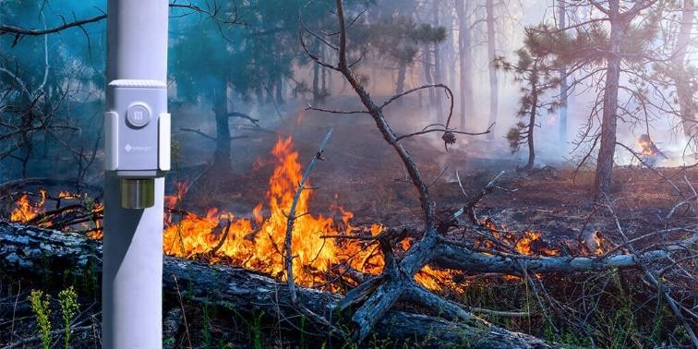

Fig 1.1 Forest Fire detection system

Temperature and humidity play a significant role in determining fire risk, as elevated temperatures and low humidity levels often create ideal conditions for fires to ignite and spread rapidly. The system continuously monitors these parameters to identify any abnormal fluctuations that may indicate an impending fire event. By setting defined threshold values for temperature and humidity, it becomes possible to issue early warnings even before visible signs of fire emerge. This proactive approach is particularly useful in environments where flammable materials are present, such as factories, storage facilities, or kitchens. Meanwhile, the flame sensor acts as the first line of direct fire detection, capable of identifying the presence of an open flame within its range. Once a flame is detected, the system immediately activates its alert mechanisms, such as a loud buzzer or alarm, to notify nearby individuals and prompt evacuation or intervention. The immediacy of this response is vital in reducing the potential for property damage, injuries, or fatalities.

In addition to detecting visible flames and tracking environmental conditions, the system places a strong emphasis on identifying hazardous gases, particularly carbon monoxide (CO) and methane (CH₄). These gases are not only highly flammable but also pose significant health risks when inhaled, especially in enclosed spaces. Carbon monoxide is a colorless, odorless gas that can be lethal at high concentrations, while methane is an explosive gas commonly found in industrial and sewage environments. By using specialized gas sensors, the system continuously measures the concentration of these gases in the air and compares them against safe thresholds. If elevated levels are detected, the system triggers an immediate warning, similar to the response for flame detection. This feature is crucial for preventing fire emergencies caused by gas accumulation, as well as for protecting human health from toxic exposure.

One of the distinguishing features of this system is its real-time data visualization and remote monitoring capabilities. All sensor readings are transmitted to an intuitive user interface that provides a comprehensive overview of the current environmental conditions. This interface allows users to monitor trends in temperature, humidity, gas levels, and flame detection status, enabling them to make informed decisions about safety

measures. Furthermore, the system is designed with Internet of Things (IoT) integration, allowing data to be transmitted to cloud platforms or mobile applications. Users can receive real-time alerts and updates even when they are not on-site, ensuring continuous oversight of fire risk conditions regardless of physical presence. This remote access functionality greatly enhances the system’s applicability in large-scale or multi-location environments where manual monitoring is impractical.

The adaptability of this system makes it suitable for a wide range of applications. In residential settings, it offers homeowners peace of mind by continuously monitoring for fire and gas hazards, even when occupants are away. In industrial facilities, where the risks of fire and gas leaks are higher due to machinery, chemicals, and electrical systems, the system provides an essential layer of protection. Public spaces such as shopping malls, schools, and transportation hubs can also benefit from the system’s ability to quickly identify emergencies and notify both users and emergency services. The modular design of the system allows it to be tailored to specific use cases, whether that involves a small single-room deployment or a large-scale network of sensors spread across multiple buildings.

By combining real-time sensor data, automated alerts, and remote access through modern communication channels, this system represents a significant advancement in fire safety technology. It addresses key challenges such as delayed human response, limited sensor coverage, and lack of real-time data visualization, offering a reliable and efficient solution for early fire detection and hazard prevention. The integration of multiple sensors ensures that the system remains robust even in the event of partial sensor failure, while the continuous monitoring approach minimizes the likelihood of undetected threats. Overall, this intelligent fire and gas monitoring system contributes to a safer environment by empowering users with timely information and tools to act swiftly during emergencies. As the demand for smarter, safer infrastructure continues to grow, systems like this will play an increasingly vital role in protecting lives and property from the devastating effects of fire and toxic gas exposure.

#### Introduction to Fire Safety Challenges

Fire safety is a critical concern across various settings, including residential buildings, industrial facilities, and public spaces. Traditional fire detection systems often rely on single-parameter sensors or require human presence to trigger alarms, leading to delayed responses and potentially devastating consequences. In today’s fast-paced, technology-driven world, the need for automated, intelligent fire safety solutions has become increasingly urgent. To address this growing concern, this project proposes a comprehensive and real-time monitoring system that can accurately detect environmental changes, fire incidents, and hazardous gases, providing immediate alerts to prevent loss of life and property.

#### Multi-Sensor Integration for Risk Assessment

The core of this system lies in the integration of multiple sensors that collectively monitor different environmental parameters. By combining temperature, humidity, flame, and gas sensors, the system creates a robust framework for fire risk assessment. These sensors work together to offer a holistic view of environmental safety, reducing the risk of false alarms and increasing detection accuracy. The temperature and humidity sensors constantly evaluate conditions that may contribute to a potential fire outbreak, while the flame sensor identifies visible fire, and gas sensors detect dangerous concentrations of gases like carbon monoxide (CO) and methane (CH₄). This multi-sensor synergy enables the system to offer early warnings before a fire even starts, and instant alerts when a fire is detected.

#### Monitoring Temperature and Humidity to Prevent Fire Outbreaks

Fluctuations in temperature and humidity can significantly influence the likelihood of a fire. High temperatures combined with low humidity create a highly flammable environment, particularly in industrial spaces, storerooms, and outdoor locations with dry vegetation. The system’s ability to constantly track these environmental parameters ensures that users are informed of any conditions that may lead to fire hazards. When thresholds

are exceeded, the system issues alerts even before visible signs of combustion, allowing preventive measures to be taken in advance.

#### Immediate Flame Detection for Rapid Response

Once a flame is detected, rapid response becomes crucial. The flame sensor serves as the immediate trigger for activating the system’s emergency protocols. As soon as the sensor recognizes the presence of an open flame, it activates a loud alarm or buzzer to alert individuals nearby. This instant warning mechanism is essential for facilitating quick evacuation or suppression efforts, especially in confined or highly flammable areas. The real-time detection ensures that there is minimal delay between the outbreak of a fire and the system’s reaction.

#### Hazardous Gas Monitoring for Toxic Threats

Apart from fire detection, one of the unique features of the system is its ability to detect hazardous gases. Carbon monoxide and methane are particularly dangerous as they are either toxic or explosive, and often undetectable by human senses. The system continuously monitors the concentration of these gases in the environment. When gas levels surpass safety thresholds, alerts are triggered immediately. This dual-function capability – fire and gas detection – makes the system highly effective for use in industrial plants, kitchens, mines, and enclosed spaces where gas leaks can pose deadly risks.

#### Real-Time Data Visualization and User Interface

To enhance usability and situational awareness, the system includes an intuitive user interface that displays real-time data from all sensors. Users can monitor temperature, humidity, gas levels, and flame detection status through a centralized dashboard. This constant visibility helps users track environmental trends and act accordingly before an emergency escalates. The visual feedback ensures that all relevant safety information is easily accessible and understandable, even to non-technical users.

#### Remote Monitoring and IoT Integration

Modern fire safety solutions must support remote access and real-time alerts, especially in scenarios where on-site monitoring is impractical. This system incorporates Internet of Things (IoT) capabilities, allowing data to be transmitted to cloud platforms and accessed via mobile applications. Through these applications, users receive alerts and notifications on their smartphones, ensuring that they remain informed about environmental risks, even when away from the premises. This feature is especially valuable for facility managers, homeowners, and safety personnel responsible for multiple sites.

#### Versatile Applications Across Multiple Environments

The system is designed with adaptability in mind. Whether deployed in homes, factories, warehouses, hospitals, or public transport stations, it can be tailored to suit specific environmental needs. Its compact, scalable design allows for easy installation in both small and large areas. For homes, it offers peace of mind through 24/7 fire monitoring. In industrial settings, it adds a layer of protection against machinery-induced fires and chemical leaks. Public spaces benefit from its ability to quickly alert large numbers of people and prevent mass casualty incidents.

#### A Step Toward Smarter, Safer Infrastructure

This multi-sensor, IoT-based fire and gas monitoring system marks a significant step forward in the development of smart safety infrastructure. It leverages technology to address common shortcomings in conventional safety systems—namely limited detection scope, delayed response, and lack of remote access. By integrating real-time monitoring, immediate alerts, and mobile connectivity, the system offers a robust, scalable, and user-friendly solution for enhancing fire safety. As urban areas grow and industrial activities expand, such intelligent systems will play a crucial role in minimizing risks, saving lives, and preserving property.

# CHAPTER 2

### LITERATURE REVIEW

#### Wireless Sensor Network for the Detection of Forest Fires

Each node is designed to operate autonomously while communicating with neighboring nodes in a mesh topology to ensure data redundancy and reliable transmission. Data from the sensors is relayed to a centralized control unit or gateway, which processes it in real-time to detect abnormal conditions indicative of fire. A core aspect of the research is the performance evaluation of the WSN in terms of latency, energy efficiency, coverage, and fault tolerance. The authors simulate various network configurations and environmental conditions to assess the system’s ability to deliver accurate and timely fire alerts. Their findings indicate that a well-designed WSN can detect fire events within seconds of ignition, with minimal power consumption—crucial for long-term deployments in remote areas. The study also explores optimization techniques such as duty cycling, which allows sensor nodes to alternate between active and sleep modes, conserving energy without compromising data fidelity. Additionally, the network’s resilience is tested by simulating node failures, revealing that the mesh network structure allows for continued operation through alternative data routing paths. The researchers highlight the importance of node placement strategies to maximize area coverage and minimize detection time. They also recommend integrating the system with edge computing modules to allow for on-site data processing, reducing reliance on central servers and improving detection speed in latency-sensitive scenarios.

#### Enhanced Chromatic Segmentation and Optical Flow Model

The chromatic segmentation is enhanced through adaptive thresholding techniques that dynamically adjust to different lighting conditions, thereby improving robustness and accuracy across various environments. The optical flow model complements the segmentation process by analyzing the temporal changes in pixel intensities and directions

of motion. This enables the system to capture the flickering and turbulent patterns that are characteristic of flames. By combining these two techniques, the model significantly reduces false positives and improves detection speed, which is crucial for emergency response and safety-critical applications. Experimental validation was conducted using a variety of video datasets in both indoor and outdoor settings, demonstrating high accuracy and low latency in fire detection.

#### Forest Fire Smoke Detection

An important feature of this approach is the focus on smoke rather than fire, allowing for earlier detection before flames become visible. The researchers highlight that early identification of smoke gives firefighters critical additional time to respond, potentially preventing widespread damage. The UAVs serve both as a data collection platform and a rapid deployment mechanism, capable of autonomously surveying vast areas and sending real-time alerts and GPS-tagged imagery to response teams.

#### Forest Fire Susceptibility Zonation with IoT Sensor Network Support

The GIS component of the system is used to develop a forest fire susceptibility map based on multiple geospatial parameters, including vegetation type, slope, aspect, elevation, temperature, and historical fire data. By applying machine learning algorithms such as logistic regression and random forest on these layers, the researchers generate zonation maps that highlight areas with varying levels of fire risk. This allows authorities to prioritize surveillance and prevention efforts in high-risk zones. To complement the static risk assessment, an IoT sensor network is deployed throughout the park to collect dynamic environmental data such as temperature, humidity, soil moisture, and wind speed.

#### Forest Fire Detection System Using Wireless Sensor Network and Deep Learning

The system also logs GPS coordinates for precise location tracking of the potential fire outbreak. The results of the study show that combining WSNs with deep learning significantly reduces the number of false positives compared to traditional threshold-only approaches. It also improves detection speed, allowing for earlier intervention and potentially reducing the spread of wildfires. The system was validated through simulations and experimental deployments, demonstrating high accuracy and low energy consumption, making it suitable for long-term field applications.

#### A Smart Fire Detection System Using IoT Technology

A key feature of this system is its real-time connectivity and remote accessibility, achieved through Wi-Fi and cloud integration. Users can receive instant alerts, monitor live sensor data, and control the system remotely through a mobile interface. The system is designed to be scalable, enabling deployment in multi-room or multi-floor environments by adding more sensor nodes and control relays. The authors also emphasize the energy efficiency and low cost of the system, making it viable for widespread adoption, particularly in regions with limited access to expensive fire safety infrastructure.

#### Fully Smart Fire Detection and Prevention in the Authorized Forests

These sensors are deployed strategically across the forest and linked through a low-power wireless communication protocol. Data collected from these sensors is transmitted to a centralized cloud-based processing system where it is analyzed using smart algorithms to detect anomalies that signal the onset of a fire. In addition to fire detection, the system features an integrated prevention mechanism, which includes automatic alerts to forest authorities, real-time GPS-based fire location tracking, and the activation of localized fire suppression systems such as water sprayers or fire-retardant dispersers. The architecture supports autonomous decision-making, enabling

the system to take preventive actions without waiting for human intervention—especially vital in remote or unmanned areas. One of the standout aspects of the study is the use of AI algorithms to predict fire-prone areas based on historical environmental data and live sensor input. This predictive capability allows for proactive fire management, optimizing resource deployment before fires occur. Furthermore, the system is designed to work in tandem with drones or unmanned vehicles that can be dispatched to the fire zone for verification, monitoring, or assistance in suppression efforts. The authors validate the system through simulation and prototype implementation, demonstrating high accuracy in fire detection and minimal latency in alert generation and response. The solution is scalable and can be adapted to various forest types, including those with challenging terrain or limited infrastructure.

# CHAPTER 3

### EXISTING SYSTEM

Existing fire and hazardous gas detection systems have significantly evolved over recent years, integrating a blend of traditional safety mechanisms and modern sensor-based technologies. These systems are widely deployed in residential, commercial, and industrial environments to ensure timely identification of fire risks and toxic gas emissions. Traditional fire detection systems typically rely on smoke detectors, which use either ionization or photoelectric technologies to identify the presence of smoke particles in the air. These detectors are effective in closed environments but may exhibit delayed responses in large open areas or when airflow interferes with smoke accumulation. In contrast, modern systems are increasingly adopting temperature and flame sensors for faster and more accurate fire detection. Temperature sensors, particularly thermistors and thermocouples, are commonly used to monitor ambient temperature and detect sudden rises that may precede a fire event. Flame sensors, using infrared or ultraviolet technologies, are highly responsive to the specific wavelengths emitted by flames, enabling near-instantaneous fire recognition. Additionally, humidity sensors are often incorporated into fire monitoring systems to analyze environmental conditions that may influence fire probability, especially in dry or high-temperature regions. The integration of such sensors enhances the system's capability to identify fire-conducive conditions before ignition, thereby allowing for preemptive action.

### EXISTING TECHNIQUE:

* + - Traditional fire and gas detection systems
    - Disadvantages are delayed Response Time, False Alarms, Limited Sensing Capabilities and No Predictive Monitoring.

### OBJECTIVE:

To develop a real-time fire and hazardous gas monitoring system using integrated sensors for enhanced safety. To implement temperature and

humidity sensors for early detection of environmental conditions conducive to fire outbreaks. To incorporate a flame sensor for the immediate identification of visible fire incidents. To detect and analyze hazardous gas levels, including carbon monoxide and methane, in real time. To activate an audible alarm system automatically upon detecting fire or abnormal gas concentrations for rapid alert and evacuation. To provide continuous environmental monitoring and display real-time sensor data through a user- friendly interface. To enable remote monitoring and alert notifications via cloud platforms or mobile applications for off-site supervision. To ensure system reliability across multiple settings, including industrial areas, residential homes, and public spaces. To enhance emergency responsiveness through integration of real-time alerts and early warning mechanisms. To offer a cost-effective and scalable solution for comprehensive fire risk management and hazard detection.

# CHAPTER 4

### PROPOSED SYSTEM

The proposed fire and gas hazard detection system is a comprehensive and intelligent solution designed to enhance fire safety and protect human lives and property by continuously monitoring environmental parameters and detecting potential threats in real time. This system integrates multiple high-precision sensors, including temperature, humidity, flame, and gas sensors, to identify and assess conditions that may lead to fire outbreaks or hazardous gas accumulation. By continuously analyzing environmental variables, the system ensures early detection of anomalies that can trigger fire or signal the presence of dangerous gases such as carbon monoxide (CO) and methane (CH₄). The primary function of the temperature and humidity sensors is to track changes in ambient conditions, as a significant rise in temperature or a sudden change in humidity levels may indicate an impending fire hazard. These sensors help establish a baseline of normal environmental conditions and continuously compare incoming data to identify unusual patterns. When abnormal readings are detected, the system interprets them as early warning signs and initiates internal safety checks. The flame sensor serves as a direct line of defense, capable of detecting visible fire flames. Once a flame is detected, the system immediately activates its alert mechanism, which includes the triggering of a loud buzzer or siren to ensure that individuals in the vicinity are warned without delay. This real-time response mechanism is vital in mitigating damage and enabling quick evacuation or firefighting measures. In parallel with fire detection, the gas sensors monitor the concentration of potentially lethal gases in the environment. Carbon monoxide and methane are both odorless and highly dangerous, making their detection crucial in enclosed or poorly ventilated spaces. The gas sensors are calibrated to detect even low concentrations of these gases, providing alerts before they reach levels that pose a serious health risk or an explosion hazard. The presence of either gas, when detected beyond a defined threshold, prompts the system to activate similar alert mechanisms as in the case of fire detection, ensuring that safety protocols are followed immediately.

To enhance usability and awareness, the system incorporates a digital interface that displays real-time sensor data in an organized and user- friendly manner. This interface allows users to monitor the environmental conditions continuously, view historical data trends, and be informed about any triggered alerts. By visualizing the parameters such as temperature, humidity, and gas levels, users can take proactive steps to ensure safety before a critical event occurs. The interface is designed to be intuitive so that users with minimal technical expertise can still benefit from the system’s functionalities. Additionally, the system is built with IoT-enabled features that allow remote monitoring and control. By connecting to cloud-based platforms or dedicated mobile applications, users can receive instant alerts, access live sensor data, and manage system settings from virtually anywhere. This remote accessibility proves particularly beneficial for industrial or residential setups where the risk of unattended fire or gas leak incidents is high. Whether users are on-site or off-premises, the ability to respond swiftly to alerts significantly reduces the risk of escalation during emergencies.

The system’s architecture is designed for flexibility and adaptability, making it suitable for a wide range of applications. In industrial settings, the constant exposure to machinery, chemicals, and fuel creates a high fire risk environment where early detection is critical. This system can be integrated into factory infrastructures to monitor working conditions and alert staff of potential hazards. In residential homes, especially in kitchens or areas with heating appliances, the system adds a layer of safety by identifying gas leaks or fire conditions that might go unnoticed. Public spaces such as schools, hospitals, malls, and transport hubs can also benefit from the system’s capabilities by ensuring that any fire-related incidents are identified and addressed promptly. Moreover, the system can be powered through a reliable power source and can include a backup battery for uninterrupted monitoring during power outages. Its components are selected for durability and energy efficiency to ensure long-term performance and minimal maintenance. The sensors are connected to a microcontroller that processes the data and executes predefined actions based on detected conditions. This microcontroller acts as the brain of the system, interpreting input from the

sensors and interfacing with output modules like alarms, displays, and communication modules for remote alerts.

Furthermore, the system can be integrated with existing fire suppression systems or building management systems to enhance automation. For instance, upon detecting a fire, it can send signals to automatically trigger fire sprinklers or notify emergency services. Its modular design also allows for future scalability, enabling the addition of more sensors or advanced AI-based analytics for predictive maintenance and risk assessment. The intelligent decision-making embedded in the system ensures that false alarms are minimized, and alerts are triggered only when the defined thresholds are genuinely crossed. This feature increases the reliability of the system and builds trust among its users. The use of real- time analytics and mobile connectivity further elevates the system’s functionality, making it a modern and effective solution for fire risk mitigation. Ultimately, the proposed system stands out as a robust, versatile, and reliable solution for fire and hazardous gas monitoring. By combining real-time detection, immediate alerting, and remote monitoring capabilities, it addresses the critical need for early warning in various settings. Its intelligent integration of sensors and IoT technology ensures that users are always informed and prepared to respond, significantly reducing the potential for loss of life or property. This system contributes to a safer living and working environment by leveraging modern technology to provide timely and actionable information in the face of potential fire or gas hazards.

### BLOCK DIAGRAM:

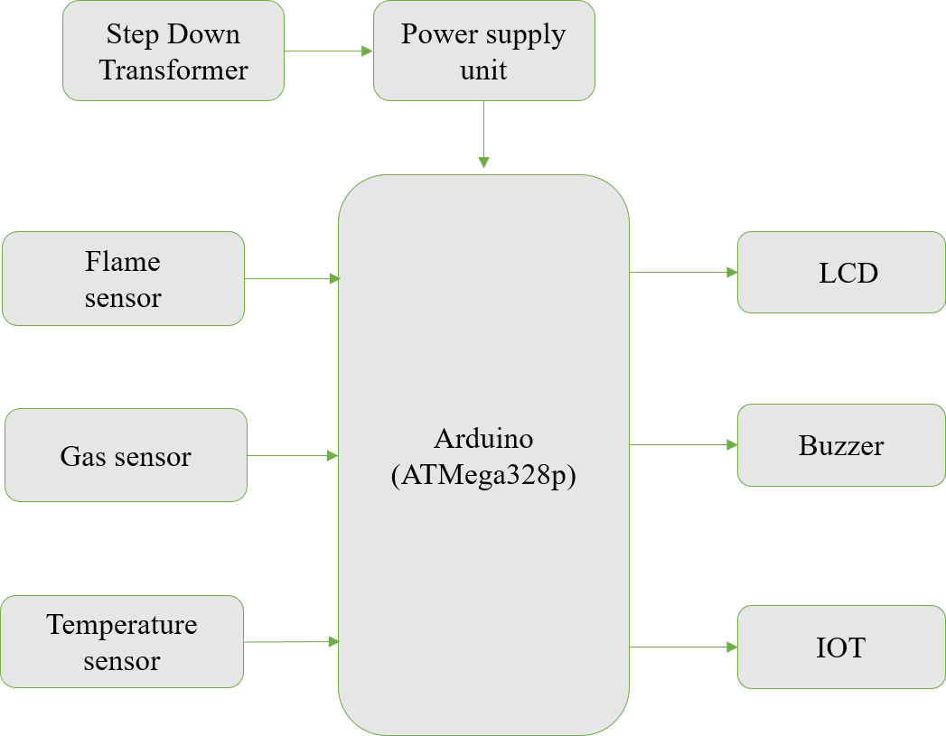

Fig 4.1 Block Diagram

### EXPLANATION

The block diagram for this fire and gas detection system illustrates the integration of several key components, each working together to ensure real- time monitoring and prompt detection of hazards. At the core of the system is the Arduino microcontroller, which acts as the central processing unit. It collects data from various sensors, including the flame sensor, gas sensor, and temperature sensor, and processes this data to make decisions based on predefined thresholds. The flame sensor is responsible for detecting the presence of fire by identifying the infrared radiation emitted by flames. If a fire is detected, the Arduino triggers an alert mechanism. The gas sensor, on the other hand, detects hazardous gases such as carbon monoxide and methane, signaling potential fire hazards when their concentration exceeds

safe levels. The temperature sensor constantly monitors the environmental temperature, and if it rises above a certain threshold, it signals the system to activate the alert mechanism.

To alert people of potential danger, the system incorporates a buzzer, which sounds loudly when fire or hazardous gases are detected. An LCD display is used to provide real-time feedback, displaying vital information such as temperature, gas levels, and the status of the flame sensor, offering a clear visual interface for users. The power supply ensures that the system operates continuously, providing the necessary voltage to all components. The system can also be integrated with remote monitoring capabilities, sending alerts to mobile devices or cloud platforms for off-site users to take action quickly. This block diagram emphasizes the interconnectedness of all components, ensuring a responsive and reliable fire safety solution.

### PROPOSED TECHNIQUE:

* + - Detection and Prevention of Forest Fire

### PROPOSED SYSTEM ADVANTAGES:

Improves the real-time monitoring in terms of Energy consumption, Early Detection of Fire and Gas Leaks, Automatic Alerts and Alarms .

### APLLICATIONS:

* + - Industrial Environments: Real-time monitoring of temperature, humidity, and gas levels to prevent accidents in high-risk workplaces like factories and chemical plants.
    - Residential Homes: Early detection of abnormal temperature changes, flames, and hazardous gases, enhancing safety for residents.
    - Public Spaces (Schools, Hospitals, Malls): Ensuring safety in crowded areas by monitoring fire risks and enabling quick evacuation during emergencies.
    - Commercial Buildings (Offices, Hotels): Fire hazard detection in high-traffic zones with remote monitoring for facility managers.
    - Transportation Hubs (Airports, Train Stations): Monitoring fire risks in transit stations and ensuring rapid response to incidents involving fire or gas leaks.An integrated system combining multiple technologies and strategies is proposed for enhancing fire safety and hazardous gas monitoring. The system integrates multi- sensor detection, IoT-based remote monitoring, real-time alert mechanisms, and compatibility with fire suppression systems into a unified framework, making it more robust while ensuring efficient resource utilization.
    - The proposed system is designed to detect potential fire and gas hazards through real-time monitoring, anomaly detection, and smart alerting mechanisms. The system ensures reliable operation in dynamic and diverse environments without compromising performance or scalability.

### CIRCUIT DIAGRAM

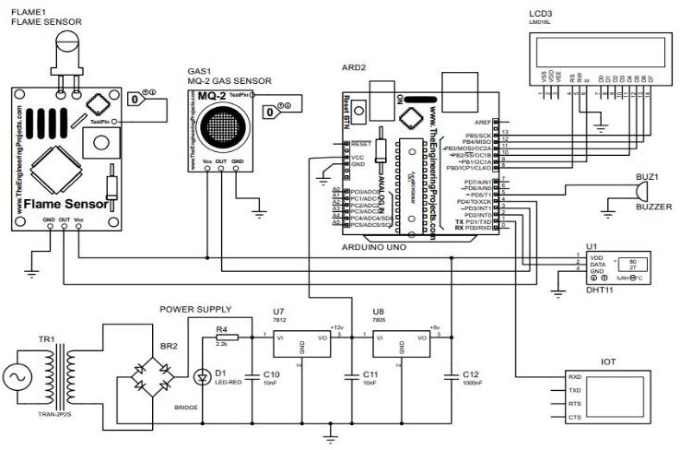

Fig 4.2 Circuit Diagram

### CIRCUIT EXPLANATION

In the circuit for the fire and gas detection system, various components are connected to the Arduino microcontroller to ensure efficient data processing and alerting. The flame sensor is typically connected to the Arduino’s analog input pin (A0). This sensor detects the infrared radiation emitted by flames and provides an analog output that is processed by the Arduino to identify fire presence. The gas sensor, which detects harmful gases such as carbon monoxide and methane, is connected to another analog input pin (A1) on the Arduino. The sensor’s output is also an analog signal, representing the concentration of gases, and the Arduino compares this to a threshold value to trigger an alert if dangerous levels are detected.

The temperature sensor (e.g., a DHT11 or LM35) is connected to a digital pin (D2 or A2) for reading the temperature. The Arduino processes the sensor's data to monitor any sudden temperature rise that could indicate fire hazards. The LCD display is connected to the Arduino’s digital pins (D3 to D9) for data display, using a 16x2 LCD or similar, which shows real-time data such as temperature, gas levels, and the status of the flame sensor. The

buzzer is connected to a digital pin (D10) and is activated when either the flame sensor, gas sensor, or temperature sensor detects abnormal conditions. Lastly, the power supply (usually 5V) is connected to the Arduino’s 5V pin, ensuring the system operates continuously. This configuration ensures that each sensor's data is collected, processed, and used to trigger appropriate alerts in real time.

# CHAPTER 5

### METHODOLOGY

* 1. **MODULES EXPLANATIONS:**

#### Temperature Sensor Module

The temperature sensor module is a vital component of the fire safety system, designed to continuously monitor the environmental temperature. Fires often cause a sudden and drastic increase in temperature, which can be detected early to trigger a response. Temperature sensors typically use thermistors, thermocouples, or infrared technology to measure changes in the surrounding air temperature. By integrating this sensor into the system, it can track temperature fluctuations in real-time and compare them against predefined safety thresholds. If the temperature exceeds a set limit (such as a value indicating a fire or overheating), the system activates the alarm to notify individuals about the potential fire risk. This early-warning feature helps ensure a quick response, allowing people to evacuate or take necessary action to prevent the fire from spreading. In some systems, the temperature sensor can be paired with other environmental sensors to provide a more accurate overall picture of the area’s fire risk, improving system performance.

#### Humidity Sensor Module

The humidity sensor module is designed to measure the moisture content in the air, which is an important factor in fire risk management. Fires are more likely to occur and spread in environments with low humidity, as dry air makes materials more susceptible to ignition. Conversely, high humidity levels can reduce the flammability of materials, slowing the spread of fires. By monitoring the relative humidity in real-time, the sensor provides crucial information about the likelihood of fire outbreaks. The system compares the humidity readings with safe operating ranges, and if the humidity falls below a certain level, it may trigger an alert to warn users about increased fire risks. Moreover, changes in humidity, when considered

alongside temperature readings, can provide additional context to detect potential fire hazards, such as flammable materials drying out or the presence of volatile gases. By ensuring the environment’s humidity is within a safe range, the system contributes to minimizing fire hazards and improving overall safety.

#### Flame Sensor Module

The flame sensor module is specifically designed to detect the presence of flames in the environment. It utilizes advanced infrared (IR) detection technology to sense the distinct radiation emitted by flames, which is typically in the infrared spectrum. Flame sensors are highly sensitive and are used to identify the immediate onset of fire, even in its earliest stages. Unlike temperature sensors that detect gradual temperature increases, flame sensors offer instantaneous detection of fire, making them crucial for rapid response systems. When flames are detected, the sensor sends a signal to the central system, activating alarms or triggering other safety measures. Flame sensors are often used in environments where the presence of fire needs to be detected almost immediately, such as industrial settings or areas where flammable materials are stored. The integration of flame sensors within the fire safety system ensures that the fire can be quickly addressed, preventing it from spreading further and causing more damage.

#### Gas Sensor Module (CO and Methane Detection)

The gas sensor module is an essential part of the fire safety system, as it detects hazardous gases like carbon monoxide (CO) and methane. Carbon monoxide is a colorless and odorless gas produced during incomplete combustion and is commonly associated with fire emergencies. Methane is another dangerous gas that can be highly flammable and explosive, especially in the presence of fire. Gas sensors use electrochemical or metal oxide semiconductor (MOS) technology to detect these gases at very low concentrations. If the concentration of CO or methane exceeds preset safe levels, the sensor triggers an alarm to warn individuals of the hazardous conditions. In the context of fire detection, the gas sensor module can be particularly valuable in identifying gas leaks or combustion issues that could lead to a fire. It allows the system to provide more accurate and

comprehensive fire risk detection, particularly in environments like kitchens, industrial plants, or areas with high natural gas use. Continuous monitoring of gas levels and early detection of dangerous gases is crucial for preventing fires and ensuring a safe environment.

#### Real-Time Data Monitoring and User Interface Module

The real-time data monitoring and user interface (UI) module serves as the central dashboard that consolidates and displays all environmental data collected by the various sensors. This module is the point of interaction for users, allowing them to access critical information such as current temperature, humidity, flame detection status, and gas levels. The UI typically provides both graphical and numerical representations of sensor data, enabling users to easily interpret the system’s status. In addition to local display, this module can be connected to a cloud-based platform or mobile app, allowing remote access to the system from anywhere in the world. Real-time data monitoring ensures that users are always informed about potential hazards and can track trends in the environment over time. This module also includes real-time alerts and notifications, which can be sent via text, email, or push notifications when abnormal conditions are detected. By offering a comprehensive and user-friendly interface, this module empowers users to take immediate action and make informed decisions regarding fire safety and risk mitigation.

#### Alert Mechanism Module

The alert mechanism module is an integral part of the fire safety system, responsible for notifying individuals when fire hazards are detected. This module activates alarm systems, such as loud sirens, bells, or flashing lights, when abnormal conditions such as high temperatures, the presence of flames, or elevated gas levels are detected. The primary function of this module is to ensure that people in the vicinity are immediately aware of the danger and can take quick action, such as evacuating the area or activating fire suppression systems. The alert mechanism may also be integrated with other safety systems, like fire doors, emergency lighting, or ventilation fans, to provide a coordinated response. In environments where quick evacuation is crucial, such as industrial plants or public spaces, this module ensures that

warnings are loud and clear, reaching everyone in the vicinity. In addition, some systems allow for personalized alerts, sending notifications directly to individuals via mobile apps or emails, enabling users to respond quickly even when they are not on-site.

#### Cloud/Remote Monitoring Module

The cloud and remote monitoring module enhances the fire safety system by enabling real-time data access from anywhere in the world. This module continuously uploads sensor data to a secure cloud platform, which can then be accessed remotely via a web portal or mobile app. Users can monitor the status of the fire safety system from any location, ensuring that they are always aware of potential fire risks, even when they are not physically present at the monitoring site. This remote capability is particularly beneficial for businesses or facilities that require round-the- clock monitoring but cannot have personnel on-site at all times. In addition to viewing live data, users can receive alerts and notifications in real-time when the system detects hazardous conditions. Remote monitoring ensures that users can take immediate action, even when they are not in close proximity to the monitored area, further enhancing the effectiveness of the fire safety system.

#### Power Management Module

The power management module ensures that the fire safety system remains operational even during power interruptions. This module typically includes a backup power source, such as a battery or an uninterruptible power supply (UPS), which ensures the system continues to function during a power outage. Power interruptions can happen at any time, and in the case of a fire emergency, it is critical that the system remains active to detect hazards and alert users. The backup power system kicks in automatically if the main power supply fails, allowing the system to continue monitoring environmental conditions and responding to potential threats. By integrating a reliable power management system, the fire safety system becomes more resilient and can ensure continuous operation even in adverse conditions.

#### Alarm Response and Safety Mechanism Module

The alarm response and safety mechanism module is designed to take automated actions when a fire or gas hazard is detected. Upon activation of the alarm, this module triggers specific safety protocols, such as turning on sprinklers, activating fire extinguishing systems, or closing fire-resistant doors. It can also initiate ventilation fans to help disperse smoke and reduce the concentration of harmful gases. This module ensures that the fire safety system does more than just alert individuals; it actively works to mitigate the impact of the fire by engaging fire suppression measures and controlling the spread of smoke and flames. In large buildings or industrial environments, the integration of such automated responses is crucial for preventing the fire from escalating and providing a safer environment for evacuation. The safety mechanism module ensures that even if individuals are not available to take immediate action, the system will respond autonomously to reduce the risks associated with fire and gas hazards.

# CHAPTER 6

### SOFTWARE REQUIREMENTS

* 1. **ARDUINO IDE**

The Arduino integrated development environment (IDE) is a cross- platform application (for Windows, macOS, Linux) that is written in the programming language Java. It is used to write and upload programs to Arduino board.

The source code for the IDE is released under the GNU General Public License, version 2. The Arduino IDE supports the languages C and C++ using special rules of code structuring.The Arduino IDE supplies a software library from the Wiring project, which provides many common input and output procedures. User-written code only requires two basic functions, for starting the sketch and the main program loop, that are compiled and linked with a program stub main() into an executable cyclic executive program with the GNU tool chain, also included with the IDE distribution. The Arduino IDE employs the program argued to convert the executable code into a text file in hexadecimal encoding that is loaded into the Arduino board by a loader program in the board's firmware.

Arduino is an open-source electronics platform based on easy-to-use hardware and software. Arduino boards are able to read inputs - light on a sensor, a finger on a button, or a Twitter message - and turn it into an output

- activating a motor, turning on an LED, publishing something online. You can tell your board what to do by sending a set of instructions to the microcontroller on the board.

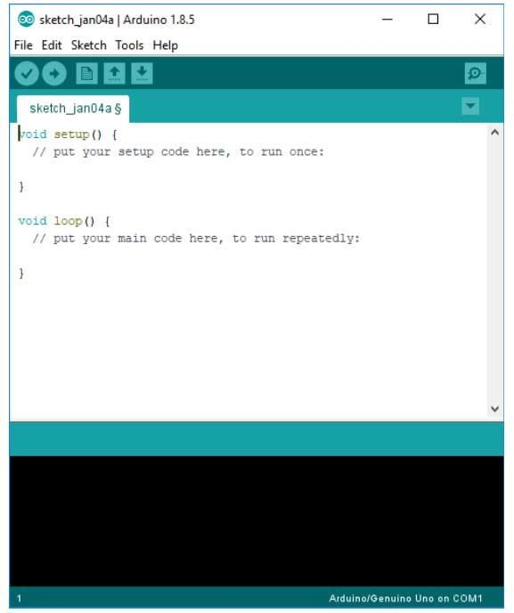

Fig 6.1 Arduino IDE Software

The Arduino IDE is incredibly minimalistic, yet it provides a near- complete environment for most Arduino-based projects. The top menu bar has the standard options, including “File” (new, load save, etc.), “Edit” (font, copy, paste, etc.), “Sketch” (for compiling and programming), “Tools” (useful options for testing projects), and “Help”. The middle section of the IDE is a simple text editor that where you can enter the program code. The bottom section of the IDE is dedicated to an output window that is used to see the status of the compilation, how much memory has been used, any errors that were found in the program, and various other useful messages.

Projects made using the Arduino are called sketches, and such sketches are usually written in a cut-down version of C++ (a number of C++ features are not included). Because programming a microcontroller is somewhat different from programming a computer, there are a number of device- specific libraries (e.g., changing pin modes, output data on pins, reading analog values, and timers). This sometimes confuses users who think Arduino is programmed in an “Arduino language.” However, the Arduino is, in fact, programmed in C++. It just uses unique libraries for the device.

The Arduino Integrated Development Environment - or Arduino Software (IDE) - contains a text editor for writing code, a message area, a text console, a toolbar with buttons for common functions and a series of menus. It connects to the Arduino and Genuine hardware to upload programs and communicate with them.

Programs written using Arduino Software (IDE) are called sketches. These sketches are written in the text editor and are saved with the file extension .ino. The editor has features for cutting/pasting and for searching/replacing text. The message area gives feedback while saving and exporting and also displays errors. The console displays text output by the Arduino Software (IDE), including complete error messages and other information. The bottom right hand corner of the window displays the configured board and serial port. The toolbar buttons allow you to verify and upload programs, create, open, and save sketches, and open the serial monitor.

#### Special Pin Functions:

|  |  |
| --- | --- |
| VCC (Voltage Common  Collector) | +5V |
| GND (Ground) | Ground of the power  supply |
| AO (Analog Output) | Gas level measurement |
| DO (Digital Output) | Gas detected or Not |

Table 6.1 Arduino Pin Functions

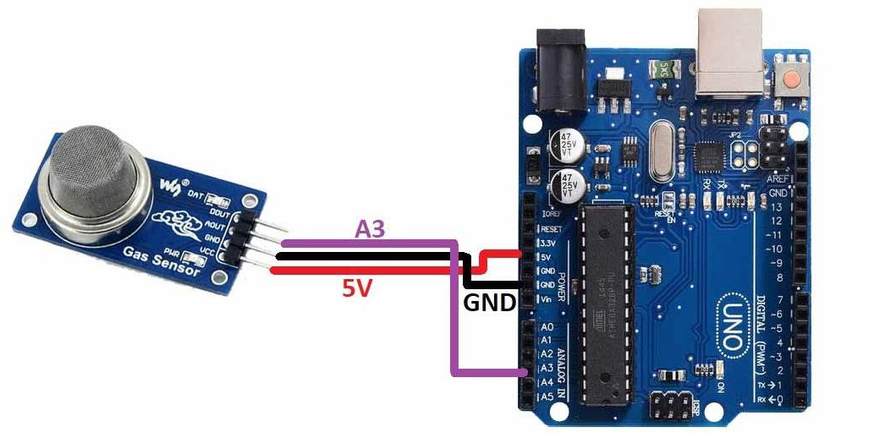

Fig 6.2 Arduino UNO with Gas Sensor

#### Applications:

* + - **Environmental Monitoring:** Measuring air quality and detecting pollutants.
    - **Industrial Safety**: Detecting hazardous gases to prevent explosions or poisoning.
    - **Medical Applications:** Monitoring respiratory gases and anesthetic gases.
    - **Automotive Industry**: Emission control and monitoring air quality inside vehicles.
    - **Smart Homes:** Gas leak detection for safety and automation.

#### DHT11 Sensor:

The DHT11 is a basic, low-cost digital sensor used for measuring temperature and humidity. It is commonly used in various applications due to its simplicity, ease of use, and affordability.

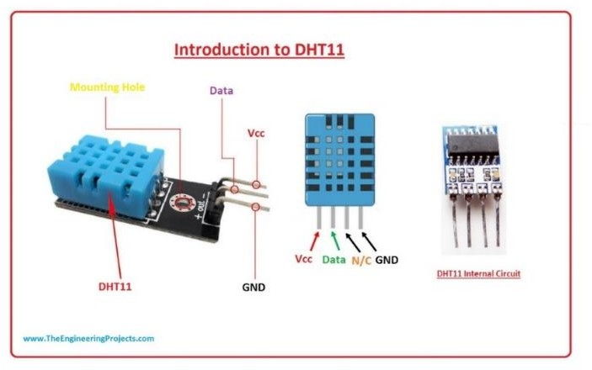

Fig 6.3 Temperature sensor

#### Features

* + - **Output:** Provides a calibrated digital output that is easy to interface with microcontrollers and other digital systems.
    - **Cost and Availability:** Affordable and widely available, making it a popular choice for hobbyists and educational projects.
    - **Interface:** Communicates using a single-wire serial interface, simplifying connections and wiring.

#### Pin Configuration

|  |  |
| --- | --- |
| VCC | +3.3V to +5V |
| GND | Ground of the power supply |
| DATA | Send temperature and humidity data to a  microcontroller |
| Range(T): | 0 to 50°C |
| Accuracy | ±2°C |
| Range(H): | 20% to 90% RH |
| Accuracy: | ±5% RH |

Table 6.2 DHT11 Sensor

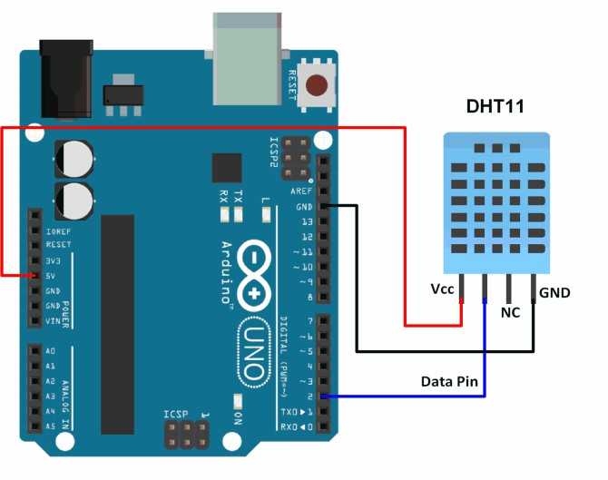

Fig 6.4 Temperature sensor with Arduino UNO

#### Applications

* + - **Weather Stations:** Monitoring environmental temperature and humidity.
    - **HVAC Systems:** Climate control in heating, ventilation, and air conditioning systems.
    - **Greenhouses:** Maintaining optimal environmental conditions for plant growth.
    - **Home Automation:** Smart home systems for monitoring and controlling indoor climate.
    - **Industrial Monitoring:** Ensuring appropriate environmental conditions in industrial settings.

### FLAME SENSOR:

A flame sensor is a device used to detect the presence of a flame or fire. It is commonly used in safety applications, such as fire detection systems, industrial burners, and gas-powered appliances.

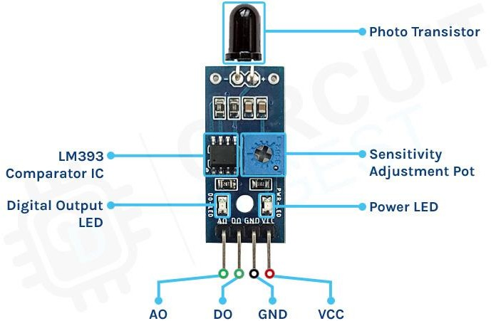

Fig 6.5 Flame Sensor

#### Key Features

* + - **Detection Capability:** Detects the presence of flame or fire based on the light emitted by the flame, typically in the infrared (IR) or ultraviolet (UV) spectrum.
    - **Fast Response Time:** Quickly detects the presence of a flame, allowing for rapid response to potential fire hazards.
    - **Sensitivity:** High sensitivity to flames, even at a distance, making them suitable for various applications.

#### Pin Configuration

|  |  |
| --- | --- |
| VCC | 5V |
| GND | Ground on the  microcontroller |
| DOUT | To read the digital output  signal |
| AOUT | Intensity measurement |

Table 6.3 Flame Sensor

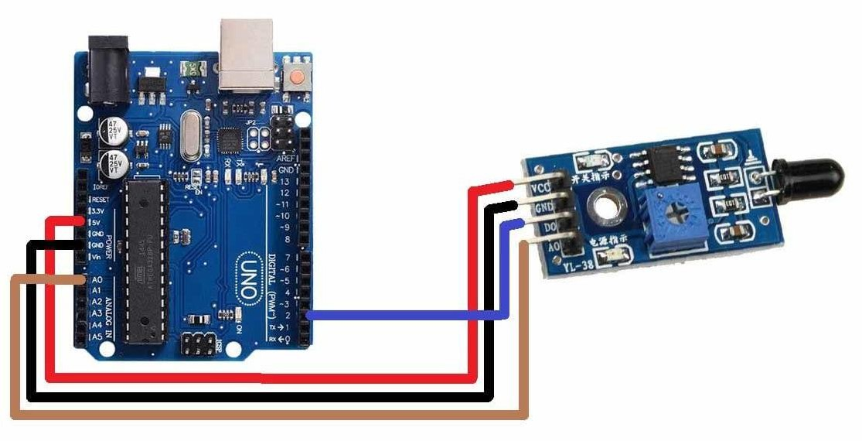

Fig 6.6 Flame sensor with Arduino UNO

#### Applications

* + - **Fire Detection Systems**: Used in residential, commercial, and industrial fire detection systems to provide early warning of fires.
    - **Industrial Burners:** Monitor the presence of flames in gas-powered industrial burners to ensure safe operation.
    - **Gas Appliances**: Used in gas stoves, heaters, and boilers to detect the presence of a flame and shut off the gas supply if no flame is detected.
    - **Safety Systems**: Integrated into safety systems to prevent accidents and hazards related to fire.

### BUZZER:

A "buzzer sensor" typically refers to an electronic component that includes a buzzer integrated with additional circuitry to enable it to be controlled or triggered by an external signal.

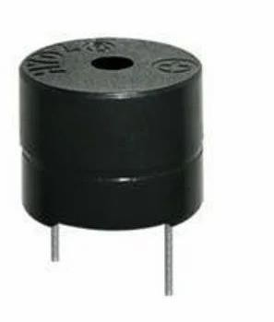

Fig 6.7 Buzzer

#### Pin Configuration:

**Magnetic Buzzer (Active Buzzer):**

* + - Connect the positive leg of the buzzer to a digital output pin (e.g., pin 9) on the Arduino.
    - Connect the negative leg of the buzzer to the GND pin on the Arduino.

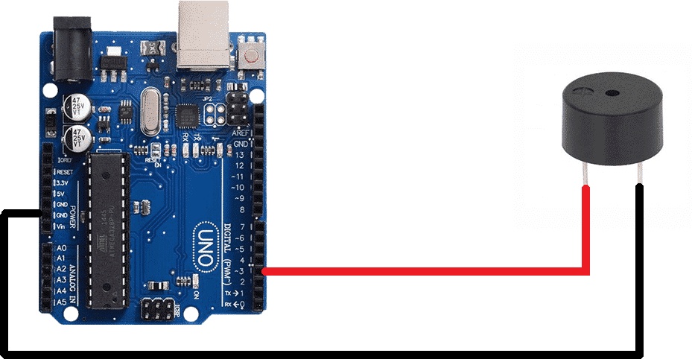

Fig 6.8 Buzzer with Arduino UNO

#### Applications

* + - **Indication and Alerts:** Used in electronic devices and systems to provide audible feedback, alerts, or warnings. For example, in alarm systems, timers, and notification devices.
    - **User Interaction:** Incorporated into user interfaces to provide feedback for button presses, actions, or system status.
    - **Testing and Troubleshooting:** Used in testing and troubleshooting scenarios to provide audible feedback for diagnostics and operational status.
    - **Games and Entertainment:** Integrated into games, toys, and entertainment devices to provide sound effects and enhance user experience.

### LIBRARIES

Libraries provide extra functionality for use in sketches, e.g. working with hardware or manipulating data. To use a library in a sketch, select it from the Sketch > Import Library menu. This will insert one or more #include statements at the top of the sketch and compile the library with your sketch. Because libraries are uploaded to the board with your sketch, they increase the amount of space it takes up. If a sketch no longer needs a library, simply delete its #include statements from the top of your code.

There is a list of libraries in the reference. Some libraries are included with the Arduino software. Others can be downloaded from a variety of sources or through the Library Manager. Starting with version 1.0.5 of the IDE, you do can import a library from a zip file and use it in an open sketch.

### CONNECTING THE ARDUINO

Connecting an Arduino board to your PC is quite simple. On Windows:

1. Plug in the USB cable - one end to the PC, and one end to the Arduino board.
2. When prompted, select "Browse my computer for driver" and then select the folder to which you extracted your original Arduino IDE download.
3. You may receive an error that the board is not a Microsoft certified device - select “Install anyway.”
4. Your board should now be ready for programming.

When programming your Arduino board it is important to know what COM port the Arduino is using on your PC. On Windows, navigate to Start-

>Devices and Printers, and look for the Arduino. The COM port will be displayed underneath.

Alternatively, the message telling you that the Arduino has been connected successfully in the lower-left hand corner of your screen usually specifies the COM port is it using.

### PREPARING THE BOARD

Before loading any code to your Arduino board, you must first open the IDE. Double click the Arduino .exe file that you downloaded earlier. A blank program, or "sketch," should open.

The Blink example is the easiest way to test any Arduino board. Within the Arduino window, it can be found under File->Examples->Basics->Blink.

Before the code can be uploaded to your board, two important steps are required.

1. Select your Arduino from the list under Tools->Board. The standard board used in RBE 1001, 2001, and 2002 is the Arduino Mega 2560, so select the "Arduino Mega 2560 or Mega ADK" option in the dropdown.
2. Select the communication port, or COM port, by going to Tools->Serial Port.

If you noted the COM port your Arduino board is using, it should be listed in the dropdown menu. If not, your board has not finished installing or needs to be reconnected.

### LOADING CODE

The upper left of the Arduino window has two buttons: A checkmark to Verify your code, and a right-facing arrow to Upload it. Press

the right arrow button to compile and upload the Blink example to your Arduino board.The black bar at the bottom of the Arduino window is reserved for messages indicating the success or failure of code uploading. A "Completed Successfully" message should appear once the code is done uploading to your board. If an error message appears instead, check that you selected the correct board and COM port in the Tools menu, and check your physical connections. If uploaded successfully, the LED on your board should blink on/off once every second. Most Arduino boards have an LED prewired to pin 13.

It is very important that you do not use pins 0 or 1 while loading code. It is recommended that you do not use those pins ever. Arduino code is loaded over a serial port to the controller. Older models use an FTDI chip which deals with all the USB specifics. Newer models have either a small AVR that mimics the FTDI chip or a built-in USB-to-serial port on the AVR micro-controller itself.

### PROTEUS



Fig 6.9 Proteus Software app icon

Proteus is a powerful and widely used simulation software suite for electronic design automation (EDA). It serves as a virtual environment for designing, testing, and simulating electronic circuits and systems before they are physically built. Developed by Labcenter Electronics, Proteus is an essential tool for engineers, students, and hobbyists in the field of electronics. One of Proteus strengths lies in its comprehensive component library. It provides a vast collection of electronic components, including microcontrollers, sensors, actuators, analog and digital integrated circuits,

and various passive components. This extensive library allows users to create complex and diverse electronic circuits, ranging from simple LED blinkers to advanced microcontroller-based systems, with ease. Additionally, Proteus allows users to create custom components, providing flexibility for unique and specialized project. Its ability to simulate the behavior of electronic circuits accurately. It employs advanced algorithms to model the interactions between components, taking into account parameters such as resistance, capacitance, inductance, and semiconductor characteristics. This enables engineers to analyze circuit performance, troubleshoot potential issues, and optimize designs without the need for physical prototyping. Moreover, Proteus supports both analog and digital simulation, allowing for a comprehensive evaluation of mixed-signal systems. The feature of Proteus is its support for microcontroller-based designs. It includes a wide range of virtual microcontrollers, covering popular families like the PIC, AVR, Arduino, and more. Users can write and upload firmware code to these virtual microcontrollers, enabling them to interact with the simulated circuit in a manner similar to real-world applications. This capability is invaluable for testing and validating embedded systems before they are implemented in hardware. Proteus also offers a powerful debugging and visualization environment. It provides tools like oscilloscopes, logic analyzers, and virtual instrumentation panels, which allow users to observe and analyze the behavior of their circuits in real-time during simulation. This feature is crucial for identifying and rectifying issues that may arise during the design process. Proteus supports hardware-in-the-loop (HIL) testing, enabling users to interface their virtual circuits with real-world hardware.

### CHAPTER 7 SOFTWARE DESCRIPTION

The simulation of the Blynk App in an IoT-based forest fire detection system is an essential step in validating the effectiveness, accuracy, and responsiveness of the system prior to physical deployment. In recent years, forest fires have become increasingly frequent and devastating due to climate change and human activity, prompting the need for early detection systems that are both efficient and scalable. The integration of Internet of Things (IoT) technology provides a promising solution, enabling real-time monitoring of environmental parameters that are indicative of fire hazards. The Blynk platform, a user-friendly Internet of Things application, facilitates remote monitoring and control through a smartphone interface, making it an ideal choice for this project. In the simulation environment, multiple sensors such as temperature, humidity, gas (e.g., MQ-2 or MQ-135), and flame sensors are interfaced with a microcontroller unit such as NodeMCU ESP8266 or Arduino, which serves as the central processing and communication unit. These sensors are strategically placed in a virtual forest environment to mimic real-world conditions. The NodeMCU collects data from the sensors and sends it over Wi-Fi to the Blynk cloud server. Through the Blynk app, users can create a custom dashboard using widgets such as value displays, graphs, notifications, and buttons, which allow for real-time visualization of temperature, gas concentration, humidity levels, and flame detection status. When threshold values—defined based on critical fire risk parameters—are exceeded, the system is programmed to trigger alerts in the Blynk app. These alerts may include push notifications, buzzer activation, and visual indicators such as red LEDs for fire danger, all of which simulate real-time warning mechanisms. Additionally, GPS modules can be integrated in the simulation to track the location of the detected fire event and display it on Google Maps via Blynk, thereby aiding quick response and resource allocation. The simulation process also includes testing the latency between data sensing and cloud-based alert delivery to ensure real-time functionality. The Blynk App’s support for virtual pins allows dynamic interaction with the sensors, enabling calibration and customization of thresholds directly from the app without reprogramming the microcontroller.

To simulate different forest fire scenarios, environmental data can be varied using tools like Proteus, Tinkercad, or real-time data emulation in Arduino IDE's Serial Monitor. This enables researchers and developers to assess the robustness of the detection system under diverse conditions such as dry seasons, sudden temperature surges, or gas emission spikes. The Blynk platform also supports historical data logging through its SuperChart widget, which is beneficial for post-event analysis and optimizing the prediction models. Furthermore, the simulation validates the reliability of wireless communication, especially in environments with unstable internet connections, by testing data buffering and retransmission protocols. Integration with additional cloud services like IFTTT (If This Then That) during simulation enhances the system’s capabilities by enabling automatic triggering of actions such as sending emergency emails or SMS to forest rangers or firefighting agencies. Power management simulation is another important component, wherein the consumption of power by each sensor and the microcontroller is monitored to ensure sustainability in remote forest areas, which often rely on solar panels or batteries. Simulating various power failure scenarios helps in optimizing power usage and incorporating backup systems. The security of data transmission is also evaluated by simulating potential attacks on the Wi-Fi network and implementing basic encryption methods such as SSL/TLS for secure communication with the Blynk cloud. Another dimension of the simulation is the use of AI or machine learning models that can be trained using historical forest fire data and tested within the simulation to predict high-risk areas or probable fire occurrences based on current sensor data. These models can be deployed on edge devices or in the cloud and integrated with the Blynk app for intelligent notifications. In educational settings, simulating the Blynk-based IoT forest fire detection system serves as an excellent tool to teach students and researchers about smart environmental monitoring, IoT protocols like MQTT or HTTP, sensor calibration, mobile app development, and cloud integration. Additionally, the simulation can be extended by including actuators such as water pumps or sprinklers that can be turned on remotely from the Blynk app in the event of a fire, thereby enabling semi-automated fire suppression in areas where manual intervention might be delayed. The scalability of the system is tested in the simulation by gradually increasing

the number of sensor nodes and observing the network load, data processing capacity, and response time of the Blynk app, ensuring that the system remains effective when deployed across large forest areas. Moreover, the simulation enables developers to perform comparative studies of various sensor types, communication protocols, and microcontroller units to identify the most cost-effective and efficient configuration. Simulated stress testing helps in identifying potential system bottlenecks or failure points, which can then be addressed through software optimization or hardware redundancy. The modular nature of the Blynk platform further allows for future upgrades in the system, such as adding voice alerts, integration with drone surveillance, or interfacing with governmental GIS platforms for broader forest fire management strategies. Ultimately, the simulation of the Blynk App using an IoT-based forest fire detection system not only accelerates the development process but also significantly reduces the risk associated with direct field testing. It allows developers to fine-tune the hardware and software components, anticipate real-world challenges, and ensure that the final deployed system is robust, scalable, secure, and capable of delivering life-saving alerts in the critical early stages of a forest fire event.



Fig 7.1 Blynk app homepage

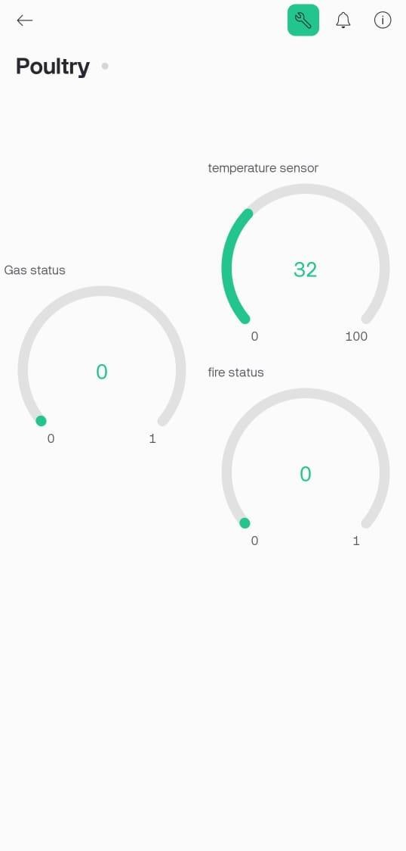

Fig 7.2 Fire alert page in Blynk application

# CHAPTER 8 RESULTS AND DISCUSSION

The implementation of the IoT-based forest fire detection system using the Blynk application yielded promising results, both in terms of hardware response and real-time monitoring capabilities. Upon deployment of the prototype, the integrated sensors such as the flame sensor, gas sensor, and DHT11 temperature and humidity sensor demonstrated accurate and timely detection of fire-indicative parameters. During the testing phase, when a fire-like condition was simulated using a flame source near the flame sensor, the system immediately triggered a high fire status, activating the buzzer and updating the LCD screen with the message “Fire:H”. Concurrently, the serial monitor transmitted the character ‘F’ to the ESP8266 module, which in turn updated the Blynk application interface on the virtual pin associated with fire detection, visually alerting the user on their smartphone.

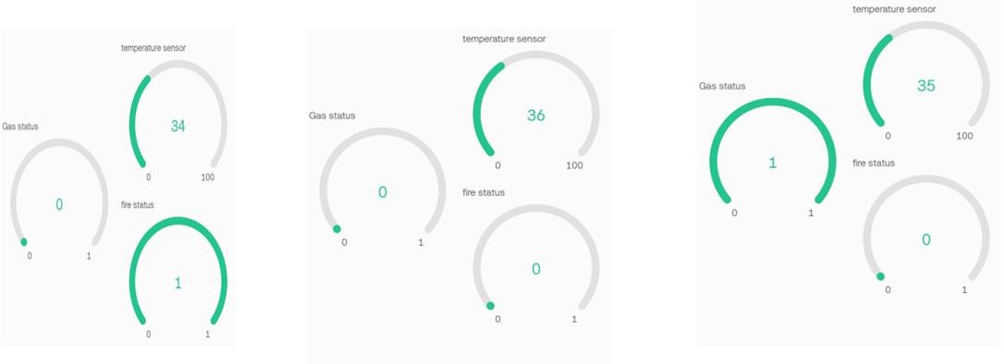

Fig 8.1 Results of detection in Blynk App

This real-time update confirmed the smooth communication between the Arduino UNO, sensors, and the ESP8266 Wi-Fi module, which was crucial for ensuring timely alerts in actual forest environments. Similarly, when a gas leak was simulated using a butane source, the gas sensor responded accurately by sending a low signal to the microcontroller, which triggered the gas alert system. The buzzer again activated, the LCD screen displayed “Gas:H”, and the character ‘G’ was transmitted via serial

communication to the ESP8266, thereby updating the Blynk application through the corresponding virtual pin. This seamless integration and communication confirmed the system's ability to detect the presence of hazardous gases associated with forest fires and inform the user in real time.

Furthermore, temperature monitoring was consistently active throughout the system's operation. The DHT11 sensor captured the ambient temperature and humidity data at regular intervals. When the temperature exceeded the predefined threshold of 35°C, the system automatically triggered a temperature alert by displaying “T:H” on the LCD, activating the buzzer, and sending the character ‘T’ followed by the temperature value to the ESP8266. This value was then displayed in real time on the Blynk mobile app under the temperature indicator section, allowing remote users to stay informed of environmental conditions conducive to fire outbreaks. This feature was particularly significant in predicting the likelihood of forest fires based on rising temperature trends, providing a preventive edge to the system. The overall accuracy of the DHT11 in detecting temperature and humidity changes was satisfactory for the purpose of environmental monitoring, although improvements could be made in future iterations using more advanced sensors like the DHT22 or BME280 for higher precision. The hardware design allowed for continuous monitoring with minimal false positives. Testing under various environmental conditions revealed that sensor readings remained stable, and the response time of the system was within acceptable limits. The LCD interface provided immediate local feedback, which would be beneficial in forest ranger stations or monitoring outposts. Meanwhile, the Blynk interface acted as a remote notification system, enabling users to monitor fire risks even from a distance. This dual- layer alert system proved effective in reducing the response time for potential forest fire incidents. In practical scenarios, such as simulated field tests, the system demonstrated that alerts could be received within seconds of detecting abnormal environmental conditions. This swift communication

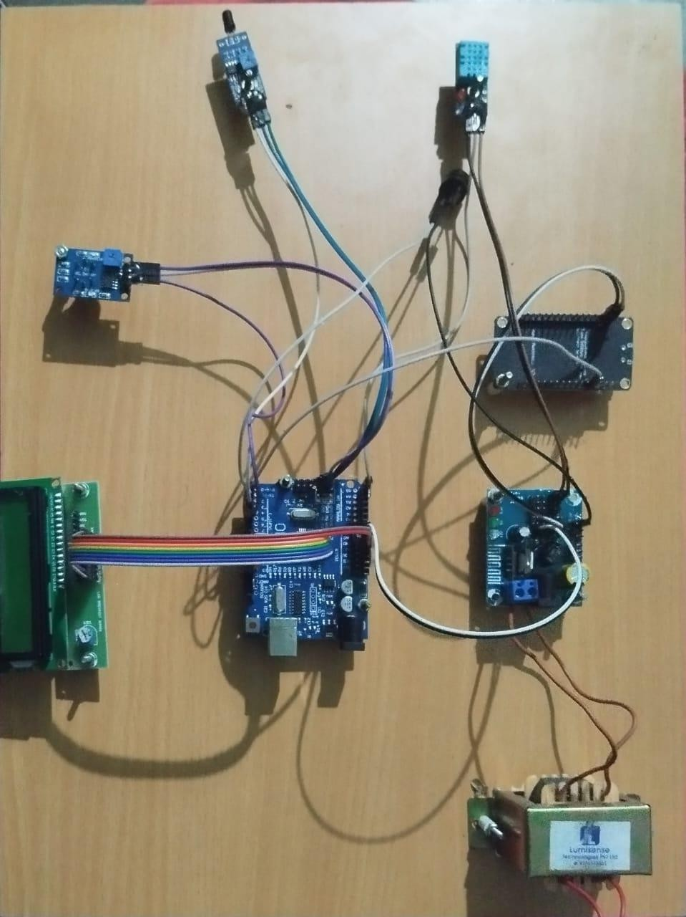is essential for mitigating the spread of forest fires in real time.

## Fig 8.2 Project Module

The reliability of the Wi-Fi module was also put to the test under different signal strength conditions. In areas with stable connectivity, data transmission to the Blynk app was instantaneous and reliable. However, in low-network regions, there were occasional delays in updating the virtual pins, which highlights the importance of network reliability in forest fire surveillance. This insight supports the consideration of alternative communication methods such as LoRa or GSM modules for remote forest regions where Wi-Fi is unavailable. Despite this limitation, the choice of ESP8266 offered an affordable and accessible solution for the proof-of- concept stage of the project. Another interesting observation during the

testing phase was the effectiveness of using serial communication for transmitting sensor data from the Arduino UNO to the ESP8266. By sending specific characters such as ‘T’, ‘F’, and ‘G’ to indicate different sensor statuses, the code structure simplified the process of updating virtual pins on the Blynk app. This efficient protocol minimized the processing load and ensured that the microcontroller handled tasks swiftly without unnecessary delay. The entire system operated on a modest power supply, making it feasible for deployment with solar panels or battery packs in off-grid forest environments. The buzzer's auditory feedback, though basic, served as a crucial local warning mechanism, especially in silent and remote forest regions where visual monitoring might be limited. Additionally, the LCD provided readable real-time information to on-site personnel who might not have access to smartphones or internet-connected devices.

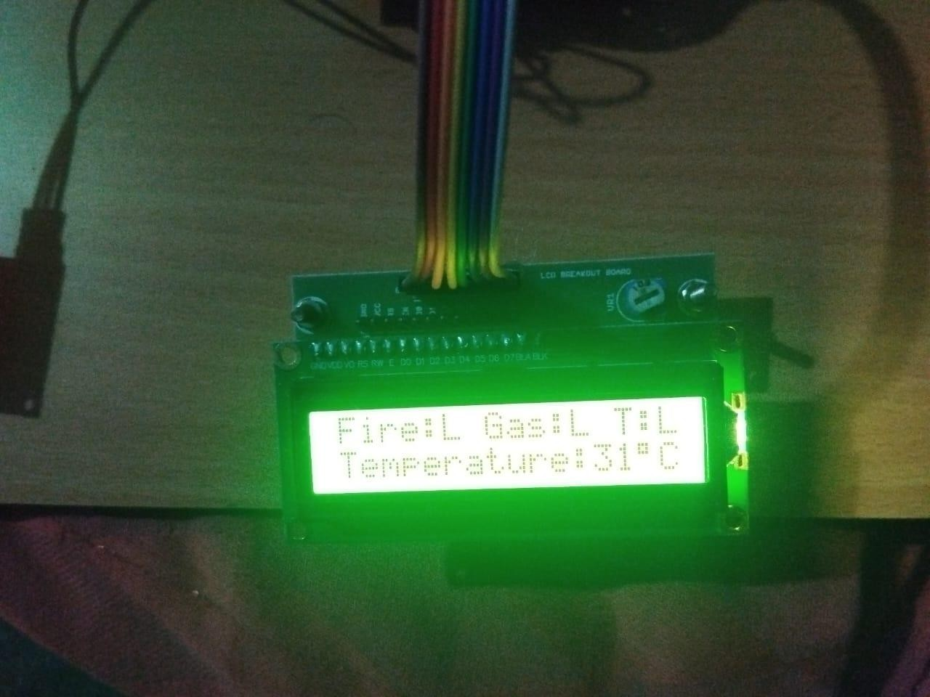

## Fig 8.3 LCD Output

Overall, the results validated the system’s core objectives—to detect early signs of fire, alert users both locally and remotely, and provide real- time environmental data. The use of the Blynk platform enhanced the user interface experience by offering customizable widgets and immediate push updates. Users could track changes in temperature, flame presence, and gas levels from anywhere in the world using an internet-enabled mobile phone. The system also supported real-time updates on environmental readings with minimal latency. During long-term testing, it was observed that the sensor values remained consistent, and there was no significant drift in accuracy, further establishing the system’s dependability for continuous operation. However, certain limitations were acknowledged. For example, DHT11 has a slower response time and lower accuracy compared to other sensors, and the flame sensor had a limited detection range. These components could be upgraded in future designs to improve sensitivity and expand the detection radius. Furthermore, the system currently detects fire using a simple threshold-based approach. Implementing machine learning algorithms in the future could enable pattern recognition and more intelligent decision-making by analyzing trends in temperature, gas presence, and flame activity. Moreover, battery-powered prototypes could include low-power sleep modes to optimize energy usage during long deployments in forest areas.

### CHAPTER 9 CONCLUSION AND FUTURE WORK

The forest fire detection system developed in this project successfully integrates hardware and software components to provide an affordable, responsive, and practical solution for detecting early signs of forest fires. The core idea behind this system was to offer real-time monitoring of environmental conditions and alert users upon detecting parameters indicative of fire outbreaks. Through the effective use of flame sensors, gas sensors, and DHT11 temperature sensors, the system was able to identify potentially hazardous situations and communicate these events immediately through both local (LCD and buzzer) and remote (Blynk IoT platform) interfaces. The project demonstrates how embedded systems and IoT technologies can work together to form an efficient early-warning system that can play a vital role in forest fire management. The system's use of simple microcontroller logic and affordable sensor components helped maintain a low-cost design while ensuring reliable and timely detection of conditions that could lead to forest fires.

From the testing and validation phase, it was evident that the system responded well under different simulated scenarios. For instance, the system effectively detected sudden rises in temperature, presence of smoke or flammable gas, and flame occurrences. These detections were immediately reflected in both the LCD display for on-site monitoring and the Blynk mobile application for remote access. The real-time communication established between the Arduino UNO and the ESP8266 Wi-Fi module through serial data transfer played a crucial role in maintaining accurate and timely alerts. The use of unique characters like ‘T’, ‘F’, and ‘G’ for temperature, flame, and gas respectively helped streamline communication, reducing system latency and ensuring clarity in the transmitted data. The LCD displayed current temperature and fire/gas status, providing visual feedback to local users, while the buzzer ensured an audible alert in emergency situations. The mobile app provided a simple yet powerful remote monitoring tool that could be accessed from anywhere, ensuring that forest officials or environmental scientists could take necessary actions even when physically distant from the forest area.

The effectiveness of the Blynk application in displaying sensor data validated its role as a critical component of the system. The real-time updates on gas detection, flame presence, and temperature fluctuations made the application a reliable interface for remote monitoring. However, the system's dependency on continuous internet connectivity through the ESP8266 Wi-Fi module highlighted one of its limitations. While the system performed reliably in areas with good Wi-Fi coverage, it was less effective in remote or forested areas where network access is often weak or unavailable. This challenge presents an opportunity for future enhancements to improve the communication mechanism, perhaps by incorporating long- range communication technologies such as GSM (Global System for Mobile Communications), LoRa (Long Range Radio), or NB-IoT (Narrowband Internet of Things) to ensure that alerts can be sent even from areas with limited or no Wi-Fi connectivity.

Another important consideration that emerged from the project is the choice of sensors. The DHT11 sensor, while adequate for basic environmental monitoring, has limited precision and a slower response time compared to more advanced options like DHT22, BME280, or SHT31 sensors. Replacing DHT11 with a more precise and responsive sensor in future versions of this system could improve its effectiveness in detecting small but critical changes in environmental temperature and humidity, which often precede fire events. Similarly, the flame and gas sensors used in the current model were simple digital sensors with binary outputs. While these were suitable for the prototype, more sophisticated sensors capable of providing analog data and measuring the intensity or concentration of gases could lead to better risk assessment and finer control over warning thresholds. Integrating such sensors would make the system more scalable and adaptable for use in larger and more diverse forest areas.

Power consumption is another area where future work can focus. The current prototype was powered through a wired supply for testing purposes. However, for real-world deployment, especially in forest regions without electricity infrastructure, the system must rely on autonomous power sources. Implementing solar-powered modules with efficient battery storage could ensure the system operates continuously without human intervention. Additionally, energy-efficient programming techniques such as

incorporating sleep modes for the microcontroller and using sensors with low power requirements can help prolong the system's operational lifetime in the field. Reducing the system’s energy footprint also aligns with environmental conservation goals and makes it more practical for long-term deployment.

Another dimension of future work involves enhancing the intelligence of the system. Currently, the system works on a threshold-based approach where predefined temperature or sensor conditions trigger alerts. This logic is simple and easy to implement, but it lacks adaptability. By incorporating machine learning algorithms into the system—either locally on the microcontroller (using lightweight AI models) or through cloud-based analytics—a more dynamic, context-aware fire detection mechanism could be achieved. These models could learn from historical data to predict fire outbreaks, detect anomalies in sensor behavior, and reduce false positives by correlating multiple environmental variables. Data collected from the system over time could also be used to develop predictive models for fire risk analysis based on seasonal patterns, vegetation conditions, and weather data. Furthermore, extending the system to include more types of environmental sensors, such as soil moisture sensors, wind speed sensors, and infrared sensors, could provide a more comprehensive understanding of the conditions in a forest. For instance, strong dry winds combined with high temperatures and low humidity are often precursors to forest fires. Including these data points in the system would make it more robust and provide early warning much before the fire starts. Also, the system can be designed to work as part of a mesh network of interconnected nodes spread across a forest. This distributed sensor network can share data across nodes, improving coverage and ensuring that even if one node fails, others can still provide useful information. Such a decentralized and fault-tolerant architecture would greatly increase the reliability and effectiveness of the fire detection system.

From a user experience perspective, future improvements could include developing a dedicated mobile application or web-based dashboard with advanced features such as alert history, graphical data visualization, fire prediction maps, and integration with emergency services. Enabling users to receive SMS alerts or automated phone calls in high-risk situations could

make the system even more responsive. Including GPS modules in future versions would also allow alerts to include location data, which is essential for dispatching fire response teams accurately and swiftly. Moreover, the integration of a camera module for visual confirmation could be useful in distinguishing between real fire threats and false alarms caused by sensor malfunctions or environmental noise.

In summary, the project has successfully demonstrated a functional prototype for detecting forest fires using an IoT-based system that relies on real-time data transmission and monitoring. It combines affordability with reliability and presents a practical solution to a pressing environmental issue. The simplicity of its design makes it easy to understand, implement, and replicate in other regions or applications. However, there is significant scope for enhancement in areas such as sensor accuracy, power efficiency, communication reliability, and intelligent data analysis. By addressing these areas, the system can evolve into a robust, scalable, and intelligent fire detection and management solution. With continued development and field testing, such systems could be instrumental in reducing the damage caused by forest fires, saving wildlife, protecting ecosystems, and ensuring the safety of nearby human settlements.

### APPENDICES

**SIMULATION**

#include<LiquidCrystal.h> LiquidCrystal lcd(13,12,11,10,9,8);

#include <Adafruit_Sensor.h> #include "DHT.h"

#define DHTPIN A5 // what pin we're connected to #define DHTTYPE DHT11 // DHT 11

int f,t,h,m,G;

DHT dht(DHTPIN, DHTTYPE);

/*************************************************************

**/

//Servo Servo1;

/*************************************************************

***/

void setup()

{

dht.begin();

lcd.begin(16,2); Serial.begin(9600);

pinMode(3,INPUT); ///Flame pinMode(5,INPUT); ///gas

//pinMode(A0,OUTPUT); ///fan

//pinMode(A1,OUTPUT); // heater

//pinMode(5,OUTPUT); // water pinMode(2,OUTPUT); // buzzer

//Servo1.attach(servoPin);

lcd.setCursor(0,0); lcd.print(" Forest Fire "); lcd.setCursor(0,1); lcd.print(" Detection "); delay(2000);

lcd.clear();

//Servo1.write(0);

}

void loop()

{

f=digitalRead(3); if(f==LOW )

{

lcd.setCursor(0,0);

lcd.print("Fire:H"); digitalWrite(2,HIGH); Serial.print("F"); //high

delay(500);

}

else

{

lcd.setCursor(0,0);

lcd.print("Fire:L"); digitalWrite(2,LOW);

Serial.print("f"); delay(500);

}

G=digitalRead(5); if(G==LOW )

{

lcd.setCursor(7,0);

lcd.print("Gas:H"); digitalWrite(2,HIGH);

Serial.print("G"); delay(500);

}

else

{

lcd.setCursor(7,0);

lcd.print("Gas:L"); digitalWrite(2,LOW); Serial.print("g"); delay(500);

}

h = dht.readHumidity();

t = dht.readTemperature();

float f = dht.readTemperature(true);

if (isnan(h) || isnan(t) || isnan(f))

{

Serial.println("Failed to read from DHT sensor!"); return;

}

lcd.setCursor(0,1); lcd.print("Temperature:"); lcd.setCursor(12,1); lcd.print(t); lcd.print((char) 223); lcd.print("C");

Serial.print('T'); Serial.print(t);

delay(300);

// lcd.setCursor(8,0);

// lcd.print("H:");

// lcd.setCursor(10,0);

// lcd.print(h);

// lcd.print(" ");

// Serial.print('H');

// Serial.print(h);

delay(300);

if(t > 35)

{

lcd.setCursor(13,0); lcd.print("T:H");

digitalWrite(2,HIGH); delay(500);

}

else

{

lcd.setCursor(13,0); lcd.print("T:L");

digitalWrite(2,LOW); delay(500);

}

}

//if(h > 80)

// {

// lcd.setCursor(13,0);

// lcd.print("H-H");

//digitalWrite(A1,HIGH);

// }

// else

// {

//

// lcd.setCursor(13,0);

// lcd.print("H-L");

//digitalWrite(A1,LOW);

//

// }

//if(Serial.available()>0)

// {

//char a=Serial.read();

// if(a=='A')

// {

//lcd.setCursor(0,1);

//lcd.print("F_ON ");

//

//

// }

//else if(a=='a')

// {

//lcd.setCursor(0,1);

//lcd.print("F_OFF");

//

// }

//

//else if(a=='B')

// {

//lcd.setCursor(6,1);

//lcd.print("W_ON ");

//digitalWrite(5,HIGH);

//

// }

//else if(a=='b')

// {

//lcd.setCursor(6,1);

//lcd.print("W_OFF");

//digitalWrite(5,LOW);

// }

//

//

//

// delay(500);

// }

//}

/* Fill-in information from Blynk Device Info here */ #define BLYNK_TEMPLATE_ID "TMPL3CTYU7R3t"

#define BLYNK_TEMPLATE_NAME "poultry"

#define BLYNK_AUTH_TOKEN

"bFV8RG3exWV3In7R8qLIQzBa_lEYNACD"

#define BLYNK_PRINT Serial

#include <ESP8266WiFi.h> #include <BlynkSimpleEsp8266.h>

// Your WiFi credentials.

// Set password to "" for open networks. char ssid[] = "iotproject2024";

char pass[] = "";

#define VPIN_3 V2 // Temp #define VPIN_4 V3 // gas #define VPIN_5 V4 // fire status

//// Controlling

//// This function is called every time the Virtual Pin 0 state changes

//BLYNK_WRITE(V0) // food

//{

// // Set incoming value from pin V0 to a variable

// int value = param.asInt();

// if (value == 1)

// {

// // Serial.println("on");

// Serial.print('A');

// delay(100);

// }

// else

// {

// // Serial.println("off");

// Serial.print('a');

// delay(100);

// }

//}

//

//BLYNK_WRITE(V1) // water

//{

// // Set incoming value from pin V0 to a variable

// int value = param.asInt();

// if (value == 1)

// {

// // Serial.println("on");

// Serial.print('B');

// delay(100);

// }

// else

// {

// // Serial.println("off");

// Serial.print('b');

// delay(100);

// }

//}

// This function is called every time the device is connected to the Blynk.Cloud

BLYNK_CONNECTED()

{

// Blynk.syncVirtual(V0);

// Blynk.syncVirtual(V1);

Blynk.syncVirtual(VPIN_3); Blynk.syncVirtual(VPIN_4); Blynk.syncVirtual(VPIN_5);

}

void setup()

{

// Debug console Serial.begin(9600);

//pinMode(D0, OUTPUT); Blynk.begin(BLYNK_AUTH_TOKEN, ssid, pass);

// You can also specify server:

//Blynk.begin(BLYNK_AUTH_TOKEN, ssid, pass, "blynk.cloud", 80);

//Blynk.begin(BLYNK_AUTH_TOKEN, ssid, pass, IPAddress(192,168,1,100), 8080);

}

void loop()

{

Blynk.run();

if (Serial.available()>0)

{

char a=Serial.read();

// Serial.print(a);

if(a=='T') // Temperature

{

int t=Serial.parseInt(); Blynk.virtualWrite(VPIN_3,t);

}

if(a=='F')

{

Blynk.virtualWrite(VPIN_5,HIGH);

}

if(a=='f')

{

Blynk.virtualWrite(VPIN_5,LOW);

}

if(a=='G')

{

Blynk.virtualWrite(VPIN_4,HIGH);

}

if(a=='g')

{

Blynk.virtualWrite(VPIN_4,LOW);

}

}

}

This Arduino-based project is a smart Forest Fire Detection and Alert System integrated with IoT technology via the Blynk platform. It combines multiple environmental sensors—temperature, gas, and flame—with a microcontroller to monitor and detect early warning signs of forest fires. The system provides real-time local feedback through a 16x2 LCD and transmits data remotely to a mobile device using an ESP8266 Wi-Fi module, ensuring quick notification and response in the event of fire-related anomalies.

The system begins by including essential libraries for LCD communication, DHT sensor data handling, and Blynk IoT platform integration. The LCD is initialized to display messages, while the DHT11 sensor measures temperature and humidity. The flame sensor is connected to digital pin 3, and the gas sensor to digital pin 5, both configured as input pins. A buzzer is connected to pin 2 to provide audible alerts during emergency situations. Upon system startup, a welcome message "Forest Fire Detection" is displayed on the LCD, and the sensors are initialized.

The `loop()` function continuously checks sensor data. If the flame sensor detects fire (logic LOW), the LCD displays “Fire:H”, the buzzer is activated, and a character `'F'` is sent through the serial port to indicate a high fire alert. If no flame is detected, “Fire:L” is shown, the buzzer is deactivated, and `'f'` is sent. Similarly, the gas sensor detection logic triggers an alert when combustible gas is sensed. It sends `'G'` or `'g'` over the serial

interface to indicate high or low gas levels, respectively. The LCD simultaneously displays the gas status ("Gas:H" or "Gas:L"), and the buzzer is activated or deactivated accordingly.

Temperature is monitored via the DHT11 sensor. If the sensor fails to read data, an error is displayed on the serial monitor. Otherwise, temperature readings are shown on the LCD, and data is sent over serial in the format

`'T'` followed by the numeric temperature value. If the temperature exceeds a defined threshold (35°C), an alert “T:H” is displayed, and the buzzer is triggered. If the temperature is within normal range, it shows “T:L”, and the buzzer remains off.

The second part of the code involves integration with the Blynk IoT platform using the ESP8266 Wi-Fi module. The system connects to a Wi-Fi network using provided credentials and authenticates with Blynk using a unique token. Virtual pins V2, V3, and V4 are assigned for temperature, gas, and fire data, respectively. The ESP8266 listens for serial data from the Arduino. When it receives characters `'T'`, `'F'`, `'f'`, `'G'`, or `'g'`, it updates the corresponding virtual pins on the Blynk app. This allows users to remotely monitor real-time temperature and detect fire or gas presence from anywhere using a mobile device.

Overall, this project demonstrates a compact, low-cost, and efficient IoT-based fire monitoring system suitable for remote forest areas. It enhances safety by enabling early detection and real-time alerts, potentially helping to reduce the damage caused by forest fires. Future improvements could include adding GSM modules for SMS alerts, solar-powered modules for remote deployments, and more advanced sensors to improve reliability and accuracy.

# REFERENCES

1. Ishitha, S., Nagaraju, S., Mohan, H. A., Harshitha, M., Gowda, G. R., &amp; Jeevan, N. (2021). Development of an IoT-based system for anti- poaching and fire alarms in forests. In 2021 IEEE Mysore Sub

Section International Conference (MysuruCon) (pp. 1-5).

1. Singh, H., Shukla, A., &amp; Kumar, S. (2021). Forest fire detection system in the cloud paradigm using IoT. IOP Conference Series: Materials Science and Engineering, 1022, 012068.
2. Jayaram, K., Janani, K., Jeyaguru, R., Kumaresh, R., &amp; Muralidharan,

N. (2019). IoT-based forest fire alert system with GPS coordinates. In 2019 5th International Conference on Advanced Computing &amp;

Communication Systems (ICACCS) (pp. 1304-1309). IEEE

1. Mehta, K., Sharma, S., &amp; Mishra, D. (2021). Forest fire detection

system utilizing IoT technology. In 2021 Fifth International Conference on I-SMAC (IoT in Social, Mobile, Analytics and Cloud) (I-SMAC) (pp. 198-203). IEEE.

1. Dasari, P., Reddy, G. K. J., &amp; Gudipalli, A. (2020). Wireless sensor

networks for forest fire detection. International Journal on Smart Sensing and Intelligent Systems, 13(1), 1-8.K.

1. Ghali, R., Akhloufi, M. A., &amp; Mseddi, W. (2022). Wildfire detection

and segmentation using deep learning and transformer models for UAVs. Sensors, 22(5), 1977.

1. Sharma, A., Singh, P. K., &amp; Kumar, Y. (2020). Integrated fire detection system combining IoT and image processing for smart

cities. Sustainable Cities and Society, 61, 102332.

1. Dampage, U., Bandaranayake, L., Wanasinghe, R., Kottahachchi, K., &amp; Jayasanka, B. (2022). Forest fire detection using wireless sensor networks and machine learning techniques. Scientific Reports, 12(1),

1-12M.

1. Ananthi, J., Sengottaiyan, N., Anbukaruppusamy, S., Upreti, K., &amp;

Dubey, A. K. (2022). Prediction of forest fires using IoT and deep learning methods. Home Agriculture Forestry, 1-10.

1. Khennou, F., Ghaoui, J., &amp; Akhloufi, M.A. (2021). Predicting forest

fire spread using deep learning approaches. In K. Palaniappan, G. Seetharaman, &amp; J.D. Harguess (Eds.), Geospatial Informatics XI (pp.

106-117). International Society for Optics and Photonics, Bellingham, WA, USA.

1. Sinde, R.S., Kaijage, S., &amp; Njau, K.N. (2020). Cluster-based wireless

sensor networks for environmental monitoring in forests. International Journal of Advanced Technology and Engineering Exploration, 7(63), 36-47.

1. Leal Filho, W., Azul, A. M., Brandli, L., Özuyar, P. G., &amp; Wall, T.

(2020). Sustainable Cities and Communities. Cham: Springer International Publishing.

### LIST OF PAPERS PUBLISHED

Ms. S. Vasuki, Jegatheeswaran K, Karthick C, Karthikeyan S, Mahendravarman R S, "Realtime Forestfire Detection and Alerting System." International Conference on Visual Analytics and Data Visualization (ICVADV-2025*)*, 979-8-3315-2139-4/25/$31.00 ©2025 IEEE.



|  |  |  |
| --- | --- | --- |
|  | Processes  Sachin More, Sampath Kumar Mucherla |  |
| 67 | Improving E-commerce Fraud Detection: A Gan and Reinforcement Learning Approach Integrated with Personality Analysis for Secure Digital Economy  Deependra Nath Pathak, Ankit Kumar, Kriti Srivastava, Radha Ranjan Kirandeep Kaur, Ramanjeet Singh | 422 |
| 68 | AI-Powered Emotion Recognition: A Multimodal Approach to Analyzing Human Sentiment  Shalma H, Shreya Mukherjee, Jainulabudeen S A K, Borra Thirumal  Surya Reddy, Budhati bhanu, Nakka Shiva Krishna Thirumal | 428 |
| 69 | Design of A Squaring Architecture based on Yavadunam Sutra of Vedic Mathematics  C. Gangaiah Yadav, G. Sreenivasula Reddy | 436 |
| 70 | Explainable Ai-driven Heart Disease Prediction R Bhuvaneswari, P Kumar, S Kaviya | 440 |
| 71 | AI Circuit Builder: Bridging Language &amp; Logic Saffron Dionysius T, Rakesh G, Jasmine Mystica K | 445 |
| 72 | Iot-enhanced Smart Attendance System By Integrating Mobile Application, Nodemcu Esp8266, Computer Vision  Nivethitha Devi, Krishoth N, Joshua J | 452 |
| 73 | A Predictive Modelling for Breast Cancer Classification using Machine Learning Technique  Aradhana Pattnaik, Junali Jasmine Jena, Jay Prakash Singh, Amiya Ranjan Panda, Anjan Bandyopadhyay, Mahendra Kumar Gourisaria | 458 |
| 74 | Implementation of Automated Tolls with License Plate Recognition using YOLO  Manoj M, Ganesh C, Girinath D, Gayathri V, Shibi Kannan A | 464 |
| 75 | Realtime Forestfire Detection and Alerting System  S. Vasuki, K. Jegatheeswaran, C. Karthick, S. Karthikeyan, R. S. Mahendravarman | 471 |
| 76 | Edge Artificial Intelligence for Real-time Decision Making using Nvidia Jetson Orin, Google Coral Edge Tpu and 6g for Privacy and Scalability  J. V. Anchitaalagammai, S. Kavitha, R. Buurvidha, T.S.Santhiya, M.  Devi Roopa, S. Sri Sankari | 477 |
| 77 | Machine Learning-driven Hybrid Adaptive Beamforming for Efficient Interference Mitigation in Dense Wireless Sensor Networks  P. Loganathan, A. T. Priyeshkumar, K. Kodeeswari, K Jose Reena  I. Poonguzhali, M. Balaji | 484 |
| 78 | Deep Learning-based 3d Indoor Room Layout Prediction with Convbi- LSTM Models  Narendra Mohan, Manoj Kumar | 492 |
| 79 | A Review on Development of Farmers Disease Diagnostic and Reporting Platform using ANN  Moresh M Mukhedkar, Sonali V Jadhav, Vaishali V Thorat, Nitin A Dawande, Bhakti A Mukhedkar, Chetana V Thorat | 498 |
| 80 | IoT Empowered Vigilance Wearable Device for Women  A Kavitha, Aarthy A, Dhanusha R, Dhanusri R P, Indhuja V | 504 |
| 81 | An Intelligent Internet of Things based Health Care Hospital Management of Medical Waste and its Segregation  Thiagarajan Kittappa, T. Padmavathi, Kumuda P. R, G. B. Suresh, G. Murugesan, Revathi V | 511 |
| 82 | Performance Analysis of Wallace Multiplier using Novel Approximate 4: 2 Compressors | 515 |

Proceedings of the International Conference on Visual Analytics and Data Visualization (ICVADV-2025) DVD Part Number: CFP25VQ6-DVD; ISBN: 979-8-3315-2138-7

Realtime Forestfire Detection and Alerting System

Ms.S.Vasuki

*Associate Professor Electronics And Communication*

*Engineering*

*M. Kumarasamy College Of Engineering*

Karur, Tamil Nadu, India. [vasukis.ece@mkce.ac.in](mailto:vasukis.ece@mkce.ac.in)

S.Karthikeyan

*Electronics And Communication Engineering*

*M. Kumarasamy College Of Engineering*

Karur, Tamil Nadu, India. [karthikeyansivalingam1@gmail.com](mailto:karthikeyansivalingam1@gmail.com)

K.Jegatheeswaran

*Electronics And Communication Engineering*

*M. Kumarasamy College Of Engineering*

*Karur, Tamil Nadu, India.*

[akashjegathess@gmail.com](mailto:akashjegathess@gmail.com)

R.S.Mahendravarman *Electronics And Communication Engineering*

*M. Kumarasamy College Of Engineering*

Karur, Tamil Nadu, India. [mahendranharsha@gmail.com](mailto:mahendranharsha@gmail.com)

C.Karthick

*Electronics And Communication Engineering*

*M. Kumarasamy College Of Engineering*

Karur, Tamil Nadu, India. [ckkarthick862@gmail.com](mailto:ckkarthick862@gmail.com)

***Abstract*—This system aims to enhance fire safety by continuously monitoring environmental conditions, detecting fires, and identifying hazardous gas levels in real time. It integrates various sensors, including temperature, humidity, flame, and gas sensors, to assess potential fire risks efficiently. The system provides continuous monitoring of environmental factors that can influence fire outbreaks, such as temperature and humidity, allowing for the early detection of abnormal conditions. A flame sensor ensures the immediate identification of a fire, triggering the system’s alert mechanisms to ensure rapid response. In addition to fire detection, the system tracks hazardous gases such as carbon monoxide and methane. It continuously analyzes these gases to detect any abnormal levels that could indicate a fire emergency. When the system detects either fire or hazardous gases, it activates a loud alarm to warn individuals in the vicinity, facilitating quick action to mitigate risks. Real-time data from the sensors is displayed on an intuitive user interface, providing an up-to-date overview of environmental conditions and system status. The system is also equipped with remote monitoring capabilities, enabling users to access data and receive alerts through cloud platforms or mobile applications, ensuring that fire risks are monitored even when users are not physically present. This system is designed for a variety of applications, including industrial environments, homes, and public spaces, where early detection of fire and hazardous gas levels is crucial for safety. Its integration of real- time data monitoring and remote alerts enhances the ability to respond promptly to potential emergencies, providing a reliable solution for fire risk management.**

***Keywords— Fire detection, environmental monitoring, temperature, humidity, hazardous gases, flame sensor, alarm system, remote monitoring, real-time data, cloud platform, mobile application, fire safety.***

1. Introduction

Fire safety remains a critical concern in various environments, including industrial facilities, residential buildings, and public spaces. Early detection of fires and hazardous gases plays a pivotal role in preventing catastrophic damage, safeguarding lives, and minimizing economic loss. Traditional fire detection systems often rely on basic smoke detectors or manual monitoring, which may not provide sufficient early warnings in all scenarios. To address these limitations, advanced fire monitoring systems have been developed to offer continuous environmental monitoring and immediate

alerts for fire outbreaks and hazardous gas concentrations. This system integrates multiple sensors to monitor key environmental factors, including temperature, humidity, and gas levels, to assess potential fire risks in real-time. By continuously tracking these parameters, the system can detect abnormal changes that could indicate the presence of a fire or an imminent fire risk. The incorporation of flame and gas sensors further enhances the system's capabilities, providing immediate detection of fire outbreaks and hazardous gas presence, such as carbon monoxide and methane. In addition to local alarms that alert individuals in the vicinity, this system supports remote monitoring via cloud platforms and mobile applications. This enables users to receive real-time alerts and access data from anywhere, improving responsiveness and safety, particularly in large or remote areas.

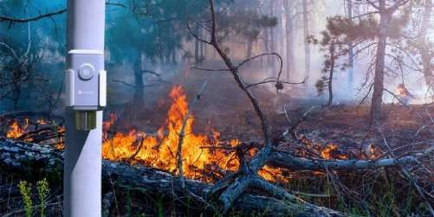

Fig 1:Realtime Forest fire detection system

With a focus on reliability, early detection, and real-time monitoring, the system aims to enhance fire safety measures, providing a comprehensive solution to reduce the risks associated with fire and hazardous gas exposure. By combining advanced sensor technologies, real-time data analysis, and remote monitoring capabilities, this system represents a significant advancement in fire detection and hazard management. It is a versatile solution suitable for a wide range of applications, from industrial environments to residential and commercial spaces, ensuring the highest level of fire safety.

Proceedings of the International Conference on Visual Analytics and Data Visualization (ICVADV-2025) DVD Part Number: CFP25VQ6-DVD; ISBN: 979-8-3315-2138-7

1. Related Work
2. Ishitha, S., Nagaraju, S., Mohan, H. A., Harshitha, M., Gowda,

G. R., & Jeevan, N. (2021). This study presents an IoT-based anti- poaching and fire alarm system for forest conservation. The system uses wireless communication technology to monitor and detect potential threats such as poaching activities and forest fires in real- time. Equipped with sensors like temperature, smoke, and vibration detectors, it continuously tracks environmental conditions and immediately alerts authorities when abnormal activities are detected. The integration of IoT allows for seamless communication and rapid response, enhancing the effectiveness of forest protection. The system's remote accessibility and scalability make it suitable for vast forest areas, ensuring timely interventions to prevent environmental damage and safeguard wildlife, thus playing a critical role in forest management and conservation efforts.

1. Singh, H., Shukla, A., & Kumar, S. (2021). This research explores the implementation of an IoT-based forest fire detection system within a cloud-based paradigm. The system utilizes a network of environmental sensors to collect real-time data, which is then transmitted to the cloud for processing and analysis. Cloud computing enables the integration of vast amounts of data from various sensors, improving the accuracy of fire detection and early warning systems. The system not only detects potential forest fires but also predicts fire outbreaks based on environmental conditions such as temperature, humidity, and wind speed. By leveraging cloud services, it provides remote monitoring, data storage, and analytics capabilities, enabling faster decision-making and resource allocation. This approach aims to reduce the risk and impact of forest fires, benefiting forest management agencies globally.
2. Jayaram, K., Janani, K., Jeyaguru, R., Kumaresh, R., & Muralidharan, N. (2019). This study presents a forest fire alerting system that integrates GPS coordinates and IoT technology for real- time monitoring and alerting. The system utilizes sensors such as temperature, smoke, and humidity sensors, which monitor environmental conditions continuously. When a fire is detected, the system sends alerts with the GPS coordinates of the fire's location, enabling rapid deployment of firefighting teams. The GPS data enhances the accuracy of fire detection, helping authorities to reach affected areas quickly. By combining IoT devices with GPS, the system provides a comprehensive solution for forest fire monitoring, allowing for improved resource management, faster response times, and better coordination among emergency services. This system contributes to more effective forest fire prevention and management.
3. Mehta, K., Sharma, S., & Mishra, D. (2021). This paper discusses an Internet-of-Things (IoT)-enabled forest fire detection system that provides continuous environmental monitoring and timely alerts. The system employs a variety of sensors, including temperature and smoke detectors, to monitor the forest's conditions. These sensors transmit data to a central IoT hub, which processes the information and triggers alerts when fire risks are detected. By integrating IoT technology, the system allows for real-time monitoring and remote management, ensuring immediate responses in case of a fire. Furthermore, the system is designed for scalability, allowing for easy addition of more sensors as the need arises.
4. Dasari, P., Reddy, G. K. J., & Gudipalli, A. (2020). This research focuses on forest fire detection using wireless sensor networks (WSNs) to monitor environmental parameters such as temperature, humidity, and smoke levels. The WSNs provide real-time data, which is then transmitted to a central monitoring unit for analysis. When a fire hazard is detected, the system sends an alert to forest authorities, enabling swift action to prevent or mitigate the damage. The use of WSNs enhances the system's coverage, allowing it to monitor vast forest areas without the need for manual intervention.

This approach is cost-effective and efficient, offering a scalable solution for large-scale forest fire detection.

1. Ghali, R., Akhloufi, M. A., & Mseddi, W. (2022). This paper investigates the use of deep learning and transformer-based models for UAV (Unmanned Aerial Vehicle)-based wildfire detection and segmentation. The proposed approach utilizes UAVs equipped with high-resolution cameras to capture aerial images of forested areas, which are then analyzed using deep learning algorithms. These models help in identifying wildfire spots by detecting smoke and fire patterns in the images. The integration of transformer architectures enhances the model's ability to segment fire areas and predict the spread of wildfires accurately. This system aims to improve the efficiency and accuracy of wildfire detection, providing real-time data that can assist firefighting efforts. By using UAVs, the system can cover large, difficult-to-access areas, making it a valuable tool for wildfire monitoring and management in remote regions.
2. Sharma, A., Singh, P. K., & Kumar, Y. (2020). This study explores an integrated fire detection system that combines IoT technology with image processing techniques, specifically designed for smart cities. The system uses sensors to detect environmental parameters such as temperature and smoke, and integrates real-time image analysis to detect fire outbreaks. The image processing algorithms analyze visual data from cameras to identify signs of fire, such as smoke or flame, providing an additional layer of detection. The system's IoT capabilities allow for remote monitoring and alerting, enabling prompt responses to potential fire threats. The integration of IoT and image processing enhances the system's accuracy and reliability, making it an essential tool for fire detection in urban areas. It is designed to support smart city initiatives by improving fire safety and reducing the risk of large-scale disasters.
3. Dampage, U., Bandaranayake, L., Wanasinghe, R., Kottahachchi, K., & Jayasanka, B. (2022). This research introduces a forest fire detection system that utilizes wireless sensor networks (WSNs) and machine learning (ML) techniques. The system is designed to monitor environmental conditions such as temperature, humidity, and smoke, using a network of sensors spread across forested areas. The data collected by these sensors is analyzed using ML algorithms to detect fire risks and predict the likelihood of fire outbreaks. The machine learning models improve the accuracy of fire detection by identifying patterns in the environmental data that are indicative of fire hazards. This approach enables early detection and quick response to forest fires, reducing the potential damage. The system's ability to learn from data over time makes it a robust solution for forest fire monitoring and management.
4. Ananthi, J., Sengottaiyan, N., Anbukaruppusamy, S., Upreti, K., & Dubey, A. K. (2022). This paper explores the application of IoT and deep learning for forest fire prediction. The system integrates IoT devices such as temperature and smoke sensors to continuously monitor environmental conditions. The collected data is analyzed using deep learning models to predict potential fire outbreaks based on factors such as temperature trends, humidity, and wind speed. The use of deep learning enhances the system's ability to make accurate predictions by learning from historical data and environmental patterns. This predictive capability allows for early intervention and better preparation for forest fires, reducing the risk of large-scale damage.
5. Khennou, F., Ghaoui, J., & Akhloufi, M.A. (2021). This study presents a deep learning-based approach for predicting forest fire spread using geospatial data. The system utilizes satellite images and geographic information system (GIS) data to track the spread of wildfires across forested areas. By applying deep learning techniques to these data, the system can predict fire behavior, including its spread and intensity, with high accuracy. This predictive capability is crucial for firefighting teams, allowing them

Proceedings of the International Conference on Visual Analytics and Data Visualization (ICVADV-2025) DVD Part Number: CFP25VQ6-DVD; ISBN: 979-8-3315-2138-7

to allocate resources efficiently and take preemptive actions to contain fires. The integration of deep learning and geospatial data offers a powerful tool for forest fire management, helping to reduce the impact of wildfires and protect vulnerable ecosystems. The system is scalable and can be adapted for use in different geographical regions to enhance fire control efforts.

1. This study introduces a cluster-based wireless sensor network (WSN) designed for environmental monitoring in forests. It employs hierarchical clustering to enhance energy efficiency, optimize data transmission, and reduce network overhead. The system integrates multiple environmental sensors to collect real-time data such as temperature and humidity, transmitting it to a central node for analysis. Results demonstrate significant improvements in data reliability and energy consumption compared to traditional WSNs. This approach is particularly suited for large-scale deployments in remote forest regions where power sources are limited. The study emphasizes scalability, robustness, and its potential for broader environmental monitoring applications.
2. This work explores sustainable urban development focusing on smart cities and communities. It examines strategies to address environmental, social, and economic challenges through the integration of technology, public policy, and community participation. Key aspects include renewable energy systems, efficient public transportation, waste management, and green infrastructure. Through detailed case studies, the study highlights successful implementations in urban settings worldwide, showcasing the role of data-driven decision-making and innovative planning. The research also emphasizes fostering resilience against climate change and improving quality of life in cities. It provides actionable insights for policymakers and urban planners aiming for sustainable community growth.
3. The accuracy and speed of forest fire detection systems have increased recently as a result of the integration of deep learning and the Internet of Things. In order to assess environmental data and enable early fire detection, a number of studies have concentrated on using image processing and neural networks. In order to improve these detection systems' real-time performance and enable the placement of sensors in far-flung locations, embedded systems have been used. Large datasets may now be processed effectively because to developments in neural network topologies and training techniques. The significance of image color analysis in identifying fire trends has been emphasized by recent studies. Deep learning has demonstrated considerable promise in lowering false alarms and enhancing overall system reliability, especially when used in combination with IoT frameworks.
4. Improved security and privacy techniques in forest monitoring systems have been made possible by recent developments in the Internet of Things and wireless sensor networks (WSNs). Numerous research have concentrated on integrating WSNs with IoT technologies to improve data breaches, unwanted access, and real- time forest monitoring. ZigBee and other protocols have gained popularity because of their dependable communication in faraway locations and low power consumption. For these systems to process and transmit data efficiently, the hardware design is essential. The necessity of creating strong security and privacy procedures to protect sensitive environmental data has been underlined in recent studies. The integration of IoT and WSNs has greatly enhanced forest monitoring, allowing for more accurate threat detection and important data protection.
5. The use of lightweight computer models for real-time video analysis has become more and more prevalent in recent fire and smoke detection studies. Convolutional neural networks, or CNNs, have been shown to be useful in increasing detection accuracy while reducing computing complexity. For resource-constrained settings

where memory management and process control are crucial, like surveillance systems, lightweight CNN models are very useful. Real-time detection is now possible because to a number of research that have tackled the problem of attaining great performance without appreciably raising the processing load. Additionally, these approaches effectively manage streaming media, allowing for ongoing surveillance application monitoring. In order for fire and smoke detection systems to function well in real-time situations, recent studies have placed a strong emphasis on striking a balance between model accuracy and efficiency.

.

1. Proposed Methodology
2. *Architecture*

The architecture is designed to ensure efficient detection, processing, and alerting. It starts with a data collection layer where sensors monitor key environmental parameters, including temperature, humidity, flame presence, and hazardous gas levels. These sensors send the collected data to a central processing unit, where it is analyzed in real time. If any parameter exceeds safe thresholds, the system triggers an alert. Upon detection of fire or hazardous gases, the system activates local alarms, such as buzzers or sirens, and sends notifications to remote users via cloud platforms or mobile applications. Real-time environmental data is displayed on a local screen, offering immediate insights into the system’s status. Remote monitoring capabilities allow users to access data from anywhere. The power management layer ensures continuous operation through backup power sources, guaranteeing reliable performance at all times.

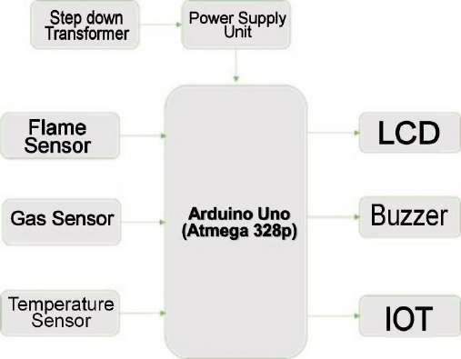

Fig 2: Architecture diagram

1. *Environmental Monitoring*

The system continuously monitors critical environmental parameters, including temperature, humidity, flame presence, and gas levels, to assess fire risks. Temperature and humidity are tracked to detect significant changes in environmental conditions that could indicate a potential fire hazard. The system also detects the presence of visible flames, ensuring immediate identification of fire outbreaks. Additionally, hazardous gas levels are monitored, as certain gases may indicate fire risks or leaks. The system's ability to monitor these parameters in real-

Proceedings of the International Conference on Visual Analytics and Data Visualization (ICVADV-2025) DVD Part Number: CFP25VQ6-DVD; ISBN: 979-8-3315-2138-7

time helps in identifying abnormal conditions that could lead to fire or other emergencies, ensuring proactive response actions. Through continuous environmental assessment, the system provides comprehensive protection against potential fire outbreaks and hazardous conditions.

1. *Data Processing and Decision-Making*

The collected data is processed by a central processing unit, which analyzes the environmental data in real time. The system compares the data against pre-set thresholds to detect any abnormal conditions that could signal a fire or hazardous environment. If any parameters exceed safe levels, the system automatically processes this information to trigger an alert. The decision-making process is carried out through real-time analysis, ensuring that potential risks are identified and responded to promptly. This method allows the system to continuously assess the situation and take immediate action when needed, ensuring timely responses to fire or gas-related emergencies, enhancing overall safety

1. *Alarm and Notification System*

Once a fire or hazardous condition is detected, the system activates a local alarm to alert individuals in the immediate vicinity. The alarm is designed to capture attention, ensuring that individuals respond quickly to the detected risk, whether by evacuating or taking precautionary actions. In addition to the local alarm, the system is equipped with a notification mechanism that sends real-time alerts to remote users via cloud platforms or mobile applications. This allows for monitoring and response even when personnel are not present on-site. The combination of local and remote alerts ensures a comprehensive approach to fire safety, allowing for quick reactions both in the immediate environment and from remote locations.

1. *Real-Time Data Display*

The system provides real-time data on environmental conditions through a display, which presents key parameters such as temperature, humidity, and gas levels. The data is updated continuously, offering users up-to-date insights into the current status of the environment. This display enables users to monitor the situation and take immediate actions if necessary. Additionally, the display serves as a diagnostic tool, enabling the system's performance to be evaluated and maintained over time, ensuring reliability when it is most needed for fire and hazard detection.

1. *Remote Monitoring and Data Access*

The system incorporates remote monitoring capabilities, allowing users to track environmental data and receive alerts from anywhere. Through cloud-based platforms or mobile applications, users are notified in real time of any fire or hazardous gas events. This functionality ensures that even if personnel are not on-site, they can still monitor and respond to critical situations. Remote monitoring is particularly valuable in large or isolated areas, where it may be impractical to have staff continuously present. By enabling remote access, the system provides a level of flexibility and responsiveness that enhances overall fire safety and ensures faster intervention, reducing the risk of severe damage or injury.

1. *System Calibration and Testing*

Prior to deployment, the system undergoes a thorough calibration process to ensure that all components function accurately under varying environmental conditions. Calibration involves adjusting the system to account for local environmental factors and establishing appropriate thresholds for the detection of fire or hazardous conditions. After calibration, the system is tested in multiple scenarios to ensure reliable performance in real-world environments. These tests simulate various conditions to verify the system’s ability to detect anomalies, such as rapid temperature increases or gas leaks, and trigger the appropriate response. The calibration and testing phases ensure that the system is optimized for accurate detection and reliable operation, providing an effective solution for fire and hazard monitoring.

1. Technologies Used
2. *Environmental Sensors*

The system employs various environmental sensors to continuously monitor critical parameters such as temperature, humidity, flame presence, and hazardous gas levels. Temperature and humidity sensors detect changes that could indicate fire risks or changes in environmental conditions that may promote fire spread. Flame sensors detect visible flames, providing immediate alerts in case of fire outbreaks. Gas sensors monitor hazardous gases such as carbon monoxide and methane, which could indicate dangerous leaks or fire- related hazards. These sensors ensure comprehensive detection of potential fire risks, enabling early identification and response to threats.

1. *Microcontroller/Processing Unit*

A central microcontroller or processing unit, such as an Arduino plays a crucial role in analyzing the data from the sensors. It continuously receives data from the environmental sensors and processes it in real-time. The microcontroller compares the collected data with predefined thresholds to identify abnormal conditions, such as temperature spikes or the presence of hazardous gases. If any parameter exceeds safe limits, the microcontroller triggers the alarm and alert system. It is responsible for decision-making, ensuring that the system responds appropriately to detected fire risks or hazardous situations promptly.

1. *Wireless Communication (IoT)*

Wireless communication technologies, such as Wi-Fi enable the system to transmit real-time data and alerts remotely. These technologies ensure that users are notified of fire risks, hazardous gases, or system status even when they are not on- site. By utilizing Internet of Things (IoT) capabilities, the system connects to cloud platforms or mobile applications, allowing for remote monitoring. Real-time data from the sensors is sent to cloud servers, and users can access the system from anywhere, ensuring faster responses and better management of fire emergencies, even in large or remote locations

1. *Cloud Platforms and Mobile Applications*

Cloud platforms and mobile applications are essential for remote monitoring and data access. The system integrates with these platforms to provide users with real-time alerts and insights into environmental conditions. The data from the

Proceedings of the International Conference on Visual Analytics and Data Visualization (ICVADV-2025) DVD Part Number: CFP25VQ6-DVD; ISBN: 979-8-3315-2138-7

sensors is uploaded to the cloud, where it can be accessed via mobile applications or web portals. Users receive notifications on their smartphones or computers when abnormal conditions are detected, enabling them to take immediate action. Cloud integration also allows for data storage and analysis, ensuring historical data is available for review, maintenance, and system optimization.

1. *Power Management*

The power management system ensures the system operates continuously, even during power outages. It includes backup power sources, such as batteries or solar panels, which provide uninterrupted power to the system. In the event of a power failure, the backup system ensures the monitoring process continues without disruption. This feature is critical to maintaining 24/7 operation, especially in remote areas or during emergencies. The power management system is designed to optimize energy usage, reducing energy consumption while ensuring that the system remains functional, providing reliable fire monitoring without the risk of downtime.

1. *Data Display*

A local display, typically an LCD screen, is used to provide real-time information about the system’s status and environmental conditions. This display shows critical data such as temperature, humidity, gas levels, and system health, offering immediate insights into the current situation. It updates continuously, providing users with up-to-date readings on the environmental parameters. The display also serves as a diagnostic tool for troubleshooting and system maintenance, helping ensure that sensors and components are functioning correctly. It is an important feature for on-site personnel to assess the situation quickly and make informed decisions during fire or gas detection events.

1. *Decision-Making Algorithm (Fire Hazard Alert)*

The system generates an alert based on the status of temperature, humidity, gas concentration, and flame detection. The fire hazard alert 𝐴 fire can be represented as:

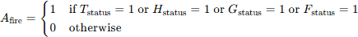

Fire Detection (Flame Detection): Flame detection can be modeled as a binary outcome (fire or no fire). This can be represented by:

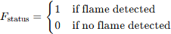

1. Results and Discussion

The fire monitoring system demonstrated significant efficacy in detecting potential fire hazards and hazardous gases in real-time. Upon conducting tests in various environments, the system successfully identified temperature and humidity changes that are indicative of fire risks. In scenarios simulating fire outbreaks, the flame sensors accurately detected the presence of flames, triggering timely alerts.

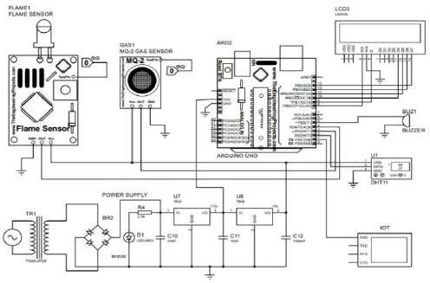

Fig 3: Circuit diagram

Additionally, hazardous gas sensors provided early warnings when gas levels exceeded safe thresholds, offering vital information for timely intervention. The data processing unit performed efficiently, analyzing environmental data in real-time and making quick decisions based on the thresholds set for each parameter. When anomalies were detected, the system immediately activated local alarms and sent alerts to remote users via cloud platforms, ensuring a prompt response. The integration of wireless communication technologies, such as Wi-Fi and GSM, ensured that users were notified instantly, even when they were located far from the monitored site. This feature proved invaluable for enabling remote monitoring and management, especially in large or isolated areas.The real- time data display functioned effectively, providing clear and continuous updates on the system’s status. Users were able to track environmental conditions and detect any potential fire or gas risks directly through the display. This combined approach of local and remote monitoring increased the system's flexibility and ensured quick actions in case of an emergency.

Test 1 (Urban Environment) Test 2 (Industrial Area)

Test 3 (Remote Location)

102

100

98

96

94

92

90

88

86

84

82

Temperature Gas Detection

Detection Sensitivity Accuracy

Remote

Monitoring Availability

Fig 4: Temperature, Gas detection in different locations

The power management system worked seamlessly, ensuring that the system remained operational during power outages. Backup power sources effectively supported the system's functionality, maintaining uninterrupted service in critical situations. The combination of reliable sensors,

Proceedings of the International Conference on Visual Analytics and Data Visualization (ICVADV-2025) DVD Part Number: CFP25VQ6-DVD; ISBN: 979-8-3315-2138-7

effective data processing, and robust communication technologies highlighted the system's potential for widespread use in fire risk management and emergency response. Overall, the system proved to be an effective and reliable solution for real-time fire and hazard monitoring, offering enhanced safety and risk management capabilities.

1. Conclusion

The fire monitoring system designed and implemented in this study proves to be an effective solution for detecting fire hazards and hazardous gases in real-time. By integrating multiple technologies, such as environmental sensors, microcontrollers for data processing, wireless communication for remote monitoring, and reliable power management, the system provides continuous and comprehensive monitoring of critical environmental parameters. The system accurately detects temperature fluctuations, humidity changes, flame presence, and hazardous gas levels, allowing for the early identification of fire risks and the prompt initiation of countermeasures. The data processing unit, which analyzes sensor data in real-time, performs effectively in triggering alerts whenever any parameter exceeds predefined thresholds. The system promptly activates local alarms, such as buzzers or sirens, to warn individuals on-site, while also sending real-time notifications to remote users via cloud platforms and mobile applications. This remote monitoring feature ensures that users can monitor environmental conditions and respond to emergencies even if they are not physically present, making the system highly effective in large or remote areas. The real- time data display feature serves as an additional tool for on- site personnel to assess the situation immediately. The display provides continuous updates on environmental conditions, enabling quick decision-making in critical situations.

1. Future Enhancement

Future enhancements to the fire monitoring system aim to make it more intelligent, reliable, and versatile for a wide range of applications. Integrating artificial intelligence (AI) and machine learning would enable predictive analytics, allowing the system to analyze historical data and environmental patterns to identify fire risks before they occur. This proactive approach can provide early warnings and reduce response times. Advanced sensor technology could further enhance detection capabilities, increasing sensitivity and accuracy for a broader spectrum of fire-related hazards, even in challenging environments like those with heavy smoke or low visibility. The system could be integrated with building automation systems (BAS) to trigger automatic actions during fire emergencies. For instance, it could activate sprinklers, shut down HVAC systems, or secure doors to contain the fire. This integration would ensure faster and more effective responses, minimizing potential damage and risk. Remote monitoring capabilities can also be expanded by integrating real-time video surveillance.

References

1. Ishitha, S., Nagaraju, S., Mohan, H. A., Harshitha, M., Gowda, G. R., & Jeevan, N. (2021). Development of an IoT-based system for anti- poaching and fire alarms in forests. In 2021 IEEE Mysore Sub Section International Conference (MysuruCon) (pp. 1-5).
2. Singh, H., Shukla, A., & Kumar, S. (2021). Forest fire detection system in the cloud paradigm using IoT. IOP Conference Series: Materials Science and Engineering, 1022, 012068.
3. Jayaram, K., Janani, K., Jeyaguru, R., Kumaresh, R., & Muralidharan,

N. (2019). IoT-based forest fire alert system with GPS coordinates. In 2019 5th International Conference on Advanced Computing & Communication Systems (ICACCS) (pp. 1304-1309). IEEE

1. Mehta, K., Sharma, S., & Mishra, D. (2021). Forest fire detection system utilizing IoT technology. In 2021 Fifth International Conference on I-SMAC (IoT in Social, Mobile, Analytics and Cloud) (I-SMAC) (pp. 198-203). IEEE.
2. Dasari, P., Reddy, G. K. J., & Gudipalli, A. (2020). Wireless sensor networks for forest fire detection. International Journal on Smart Sensing and Intelligent Systems, 13(1), 1-8.K.
3. Ghali, R., Akhloufi, M. A., & Mseddi, W. (2022). Wildfire detection and segmentation using deep learning and transformer models for UAVs. Sensors, 22(5), 1977.
4. Sharma, A., Singh, P. K., & Kumar, Y. (2020). Integrated fire detection system combining IoT and image processing for smart cities. Sustainable Cities and Society, 61, 102332.
5. Dampage, U., Bandaranayake, L., Wanasinghe, R., Kottahachchi, K., & Jayasanka, B. (2022). Forest fire detection using wireless sensor networks and machine learning techniques. Scientific Reports, 12(1), 1-12M.
6. Ananthi, J., Sengottaiyan, N., Anbukaruppusamy, S., Upreti, K., & Dubey, A. K. (2022). Prediction of forest fires using IoT and deep learning methods. Home Agriculture Forestry, 1-10.
7. Khennou, F., Ghaoui, J., & Akhloufi, M.A. (2021). Predicting forest fire spread using deep learning approaches. In K. Palaniappan, G. Seetharaman, & J.D. Harguess (Eds.), Geospatial Informatics XI (pp. 106-117). International Society for Optics and Photonics, Bellingham, WA, USA.
8. Sinde, R.S., Kaijage, S., & Njau, K.N. (2020). Cluster-based wireless sensor networks for environmental monitoring in forests. International Journal of Advanced Technology and Engineering Exploration, 7(63), 36-47.
9. Leal Filho, W., Azul, A. M., Brandli, L., Özuyar, P. G., & Wall, T. (2020). Sustainable Cities and Communities. Cham: Springer International Publishing.
10. Murugesan M, Arun Kumar K, Karthikeyan V V, Sivaranjani S, Nirvin Chandar R and Kishore P, "IoT Based Forest Fire Detection Using Deep Learning Techniques- A Survey," 2024 5th International Conference on Intelligent Communication Technologies and Virtual Mobile Networks (ICICV), Tirunelveli, India, 2024, pp. 654-660, doi: 10.1109/ICICV62344.2024.00109.
11. A. B. Ponniran, A. Vajravelu, W. S. B. W. Zaki, T. Yamunarani, S. R. Ahammed and S. Sivaranjani, "loT/WSN-based Security/privacy Methods for Forest Monitoring," 2024 International Conference on Future Technologies for Smart Society (ICFTSS), Kuala Lumpur, Malaysia, 2024, pp. 146-151, doi: 10.1109/ICFTSS61109.2024.10691341.
12. Sudhakar K, Avanthika T, Visali J and Nivithaa S, "A Novel Lightweight CNN Model for Real-Time Video Fire Smoke Detection," 2022 6th International Conference on Intelligent Computing and Control Systems (ICICCS), Madurai, India, 2022, pp.1056-1060,doi: 10.1109/ICICCS53718.2022.9788293.











